`

Table of Contents

1. Project Scope 4

2. Logon Functionality 5

3. Vehicle Arrival Functionality 6

3.1. Vehicle Arrival Screen 6

3.2. Selecting the relevant document type from the drop down lists. 8

3.2.1. Sales Inquiry 8

3.2.2. Purchase Order 9

3.2.3. Gate Pass 9

3.2.4. Document Number 10

3.2.5. Trucks collecting scrap 10

3.2.6. Rotating Trucks 10

3.2.7. Consignment Stock 11

3.2.8. Forcing a new Inspection 11

3.3. Saving the Vehicle Arrival 12

3.4. Procedure to follow when the system is offline: 13

4. Vehicle Inspection Application Functionality 14

4.1. Vehicle Inspection Screen 14

4.2. Editing Registration Details 16

4.3. Inspection Checklist 18

4.4. Saving the Vehicle Inspection 24

5. Vehicle Override Application Functionality 26

5.1. Vehicle Inspection Override Screen 26

6. Customer Service Application Functionality 29

6.1. Customer Services Screen 30

6.1.1. Truck Arrival Details 31

6.1.2. Truck Inspection Details 32

6.1.3. Order Details 33

6.1.4. Region, Queue and Product Selection 49

6.1.5. Truck Management 51

6.2. Assigning a Gatepass to a truck 53

6.3. Offline Procedure 56

6.3.1. Creation of Offline Sales Orders 56

6.3.2. Creation of Offline Inter Company Order 61

6.3.3. Creation of an Offline Gatepass 66

7. Truck Management 67

8. Packing Application Functionality 69

8.1. Packing Screen 69

9. Loading Application Functionality 74

9.1. Loading Screen 74

10. Queue Management Application Functionality 79

10.1. Queue Management Screen 80

11. Weighbridge Outbound & Inbound Side Application Functionality 81

11.1. Navigating to the correct WB order screen 82

11.2. Truck Outbound Processing 83

11.2.1. Dispatch of Sales Orders 83

11.2.2. Rejecting a load 89

11.2.3. Truck Outbound Transfer Orders 92

11.2.4. Inter – Company Transfer Orders 97

11.2.5. Stock Transfer Orders 102

11.3. Notes 102

11.3.1. Distinguishing between NGP, MSA, KSE & Mbaraki Orders 102

12. Security Application 103

12.1. Viewing the truck’s details 106

12.2. De-registering of a Truck 107

12.3. Releasing of a Truck 108

13. Pre-requisite for Mbaraki Plant Implementation & Go-live 109

14. Project Risks 110

14.1. Changes to WIMS App 110

14.2. Connection to SAP at MSA Plant 110

15. Acceptance of Functional Design Specification for Phase IV 111

# Project Scope

* The Scope of the WIMS Phase IV Mbaraki Plant Implementation Project includes the following applications:
  + Vehicle Arrival
  + Vehicle Inspection Application
  + Vehicle Inspection Override
  + Customer Service Order Assignment
  + Queue Management – Ryno Please correctly detail this process as it is currently working and add new screen dumps
  + Packing Application
  + Loading Application
  + Weighbridge
  + Production Clerk Application
  + Security Clerk Application
  + Rail Application – Ryno please add a section to the document and detail the rail process as it is currently working.

* Each application is documented, as it currently working in NGP, MSA and KSE.
* No changes will be made to any of the application, all applications will be implemented as it is.

# Logon Functionality

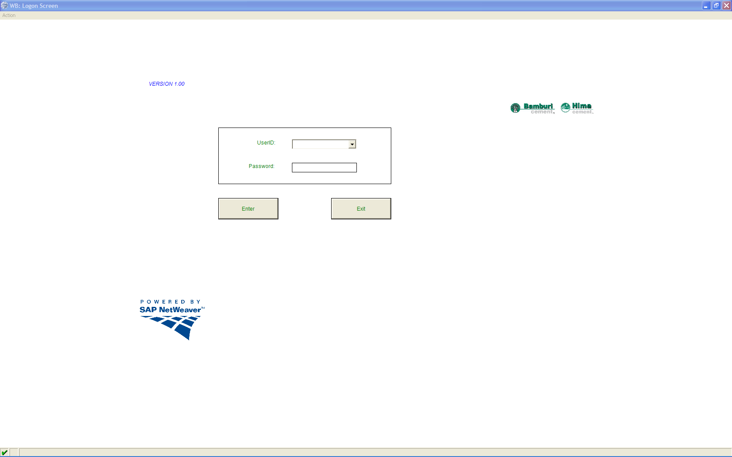

* Enter your Username & Password into the USER ID and PASSWORD fields respectively.
* Click on the  Button.
* The relevant application that the user is authorised to use, will be displayed.

# Vehicle Arrival Functionality

## Vehicle Arrival Screen

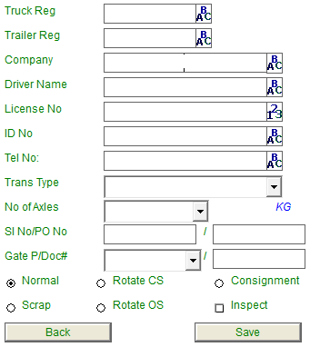

* Type the Vehicle’s Registration no into the Registration no field for example:

**(Mandatory Field)**

* **Note** that if the vehicle has previously been registered through the Application the details of the previous visit will be displayed. The user can then check the displayed details and change the fields that need to be change. For example the Driver name, Sales order no etc. If the Vehicle has not been registered through the application yet, the user will complete the rest of the fields as described below.
* Type the Trailer’s Reg no into the Trailer Reg field if the truck has a trailer:



* Type the Company’s Name into the Company name field:



* Type the Driver’s Name into the Driver Name field: **(Mandatory Field)**



Type the Driver’s License no into the License No field.



* Type the Driver’s ID no into the ID no field. **(Mandatory Field)**



* Type the Driver’s Telephone number into the Telephone no field



* Select the Transport Type from the dropdown list displayed in the Transport Type field.

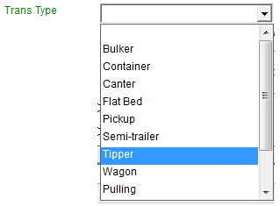

* Select the no of axles from the dropdown list displayed in the No of Axle field. **(Mandatory Field)**

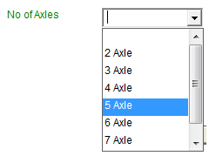

* The Max Capacity weight of the truck will automatically be displayed according to the Number of Axles selected.



## Selecting the relevant document type from the drop down lists.

Note that only one of the document types can be selected per truck.

### Sales Inquiry

* For the next step you can type in a part of the Sales Inquiry into the SI No field and then click enter. - This is for the Outbound Process when the Driver is collecting the goods.

Note that the first selection box is for the Sales Inquiries and the second selection box for the Purchase Order.



After you have clicked on the enter button the WB Sales Order list screen will be displayed.

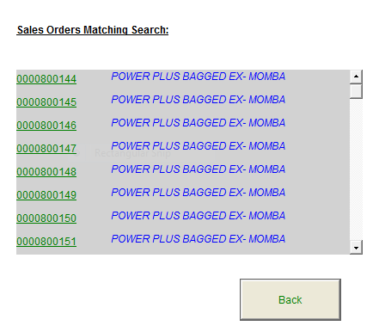

Select the relevant SI No from the list by clicking on the SI number link 

The selected SI number will be displayed in the  field.

**OR**

### Purchase Order

* Type in a part of the Purchase Order number into the PO No field and then click enter.– This is for the Inbound Process when the Driver is delivering the goods.

Note that the first selection box is for the Sales Inquiries and the second selection box for the Purchase Order.



After you have clicked on the enter button the WB Purchase Order list screen will be displayed.

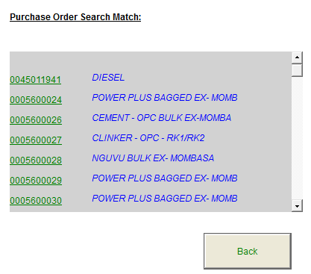

Select the relevant PO No from the list by clicking on the PO number link 

The selected PO number will be displayed in the  field.

**OR**

### Gate Pass

* You can select the Gate Pass no from the Gate Pass no field if the driver arrives with a Gate Pass document/number. (This will mostly be for Transfer Orders from Plant to Plant, Plant to Depot and Intercompany transfer orders.)

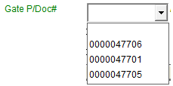

**OR**

### Document Number

* You can type a document number into the Document # field if the driver does not have any of the above document no type options (SI, PO or Gate Pass) with him.



Note that if the user cannot find the correct SI, PO or Gate Pass number in the Drop down lists, the user can click on the 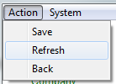 button to bring in the latest orders. If the SI, PO or Gate pass no is still not there, then there is a possibility that the system could be offline and will not bring in the latest SI and PO until it is online again. (Refer to section 3.4 of this document for the Vehicle Arrival Offline procedure)

### Trucks collecting scrap

Note that when a truck is collecting scrap, no document number will be assigned to the truck, but the Scrap option needs to be selected, in order for the system to know that the truck is collecting scrap.



### Rotating Trucks

Two types of Rotating trucks exist.

* Rotate CS
* Rotate OS

Rotate CS

Rotate CS will allow you to register a truck that will be allowed to continually rotate between plant locations during its daily operations. This truck will transfer goods without a document assigned to it, however its load and weights will be captured.

Rotate OS

Rotate OS will operate in the same way that Rotete CS operates, with the desticnt difference being that it will make use of an SAP document assigned to it, like a PO.

Both types will allow for the transfer of material for a 24 hour period as from when it is inspected.

### Consignment Stock

Consignement stock will allow for the transfer of consignment stock for a 24 hour period as from when it is inspected.

### Forcing a new Inspection

A new inspection can be forced by marking the Inspect check box. This will require that any truck that has a 24 hour or more valid inspection period be re-inspected before it may continue.



## Saving the Vehicle Arrival

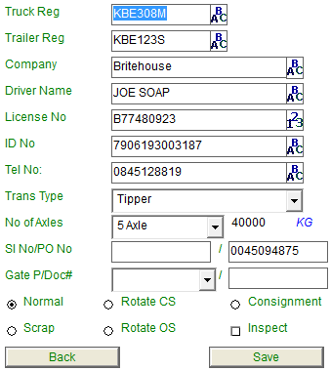

* After all the required details have been captured on the screen, click on the  Button to save the Truck’s registration.
* A dialogue box will be displayed, confirming if you want to save the truck register.

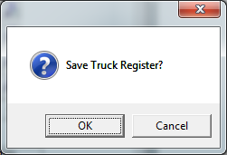

* Click on the OK button to save the Truck Register.
* A dialogue box will be displayed with a message confirming that the Truck Reg has been registered with a reference number:

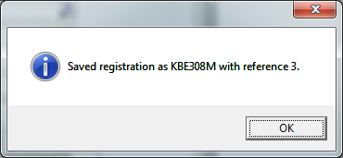

* Click on the  Button.
* Note that the screen will now be cleared automatically, for the user to do the next Truck Registration.

## Procedure to follow when the system is offline:

* **NOTE that if the system is OFFLINE** and the user cannot find the specific Sales Inquiry or Purchase Order or Gate Pass number in the respective drop down lists, the user will then have to type the relevant order no into the document # field. The users at the CSC office will then have to make sure that they link the correct order type to the truck.

# Vehicle Inspection Application Functionality

## Vehicle Inspection Screen

* The user will select the relevant Vehicle’s Registration number from the Reg no drop down box.

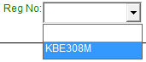

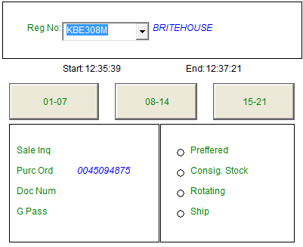

* **Note** that once the user has selected the relevant REG NO that the Order number for that vehicle will be displayed in the relevant order field for example  Purc Ord field if it was attached at arrival.
* The Customer’s name captured at Vehicle Arrival will automatically be displayed on the screen as well.
* Note: the Start field automatically captures the inspection start time:



* The End field automatically captures the inspection end time when the last inspection checklist question is completed.



## Editing Registration Details

* Note that the Arrival details captured at Vehicle Arrival can be corrected/changed by clicking on the Edit Register Option under the Action Menu Bar on the Vehicle Inspection Screen.

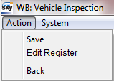

* Click on the Edit Register option.
* The Edit arrival screen will be displayed

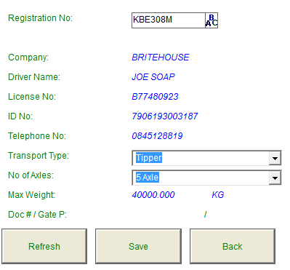

* Note that only the Truck Reg, Transport Type and No of Axles field can be changed or corrected.
* Example: Change the Transport Type from Pick up to Container.
* 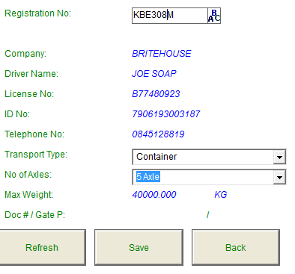
* After changing the relevant details, click on the  Button to save the changes.
* A dialogue box will be displayed confirming if you want to save the Truck register.

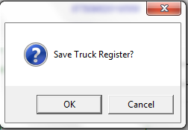

* Click on the OK button.
* The changes have been saved.
* Select the relevant Truck Reg from the  drop down box.
* The Truck’s details will be displayed on the screen.

## Inspection Checklist



* The inspection check list is divided into 3 groups:
* No 1 to 7, 8 to 14, and 15 to 21
* Click on the  Button.
* Inspection Screen One will be displayed.

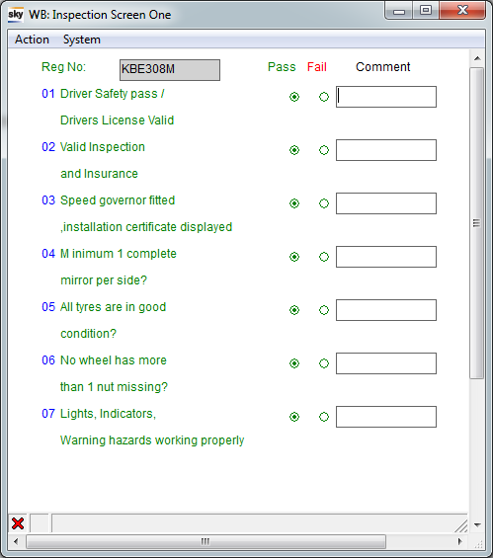

* **Note** that the Checklist will automatically select all of the Pass fields as default. The user has the option to select the Fail option and enter a comment into the Comment field next to the relevant entry if required.
* **Note** that if the a failed option is selected the system will automatically prompt the user to enter a comment next to the inspection checklist item that has been failed.
* For example: If inspection checklist no 2 is failed then the system will display the following message.

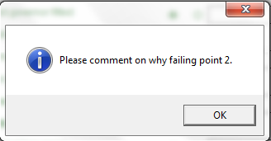

* The user will now go through the above checklist and select/enter the relevant information into fields while inspecting the vehicle.
* After the user has gone through Inspection list 1-7 he/she will click the Action Menu bar option and select the Next option to go to Checklist Two.

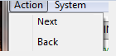

* Note that the Back option can be selected if you would like to navigate back to the previous screen.
* Inspection Screen Two will be displayed.

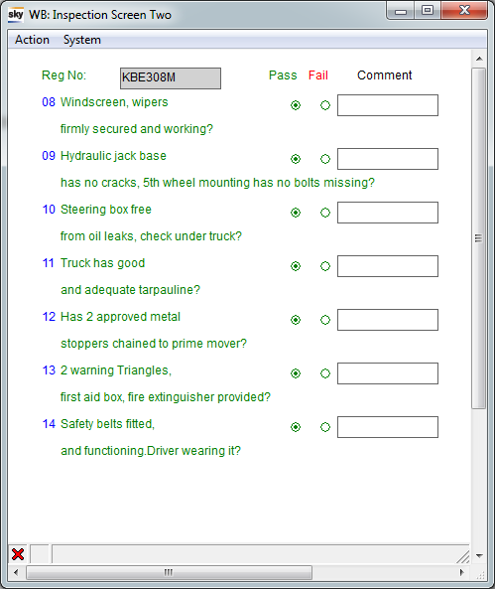

* The user will now go through the above checklist and select/enter the relevant information into fields while inspecting the vehicle.
* After the user has gone through Inspection checklist 8-14 he/she will click the Action Menu bar option and select the Next option to go to Checklist Three.



* Select the next option.
* Inspection Checklist Three will be displayed.

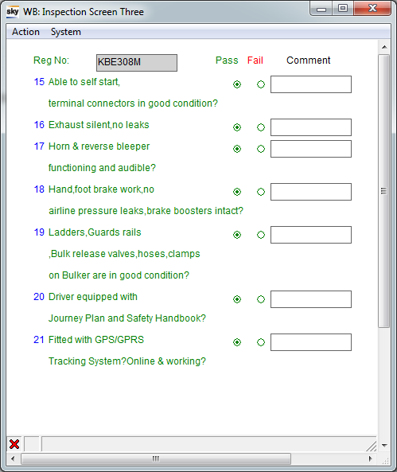

* The user will now go through the above checklist and select/enter the relevant information into fields while inspecting the vehicle.
* After the user has gone through Inspection checklist 15-21 he/ will click the Action Menu bar option and select the Done option to complete and Pass the Vehicle Inspection.

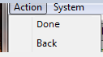

* Select the Done option
* The Vehicle Inspection screen will be displayed.

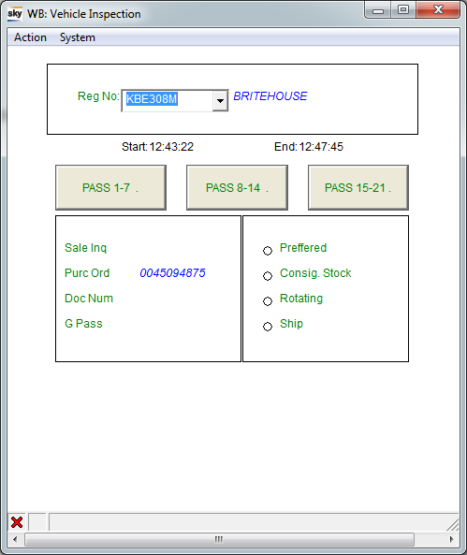

* Note that all of the Inspection Checklist Statuses have changed to Pass.
* This means that the truck has passed its inspection.

## Saving the Vehicle Inspection



* Click on the 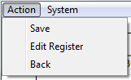Save Menu button.
* A dialogue box will be displayed confirming if you want to save the inspection.

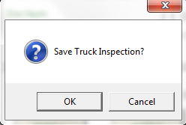

* Click on the OK Button.
* A message will be displayed at the bottom of the screen:

“Truck Inspection Completed.



* The screen will be automatically cleared so that the next Vehicle’s inspection can be done.
* NOTE that if a Vehicle inspection is FAILED, the Supervisor/Manager will still be able to OVERRIDE the inspection failure if required.
* The driver will now go to the CSC Office so that the relevant loading document/Order can be assigned to the Truck, if no order has been assigned to the truck at Vehicle arrival.

# Vehicle Override Application Functionality

## Vehicle Inspection Override Screen

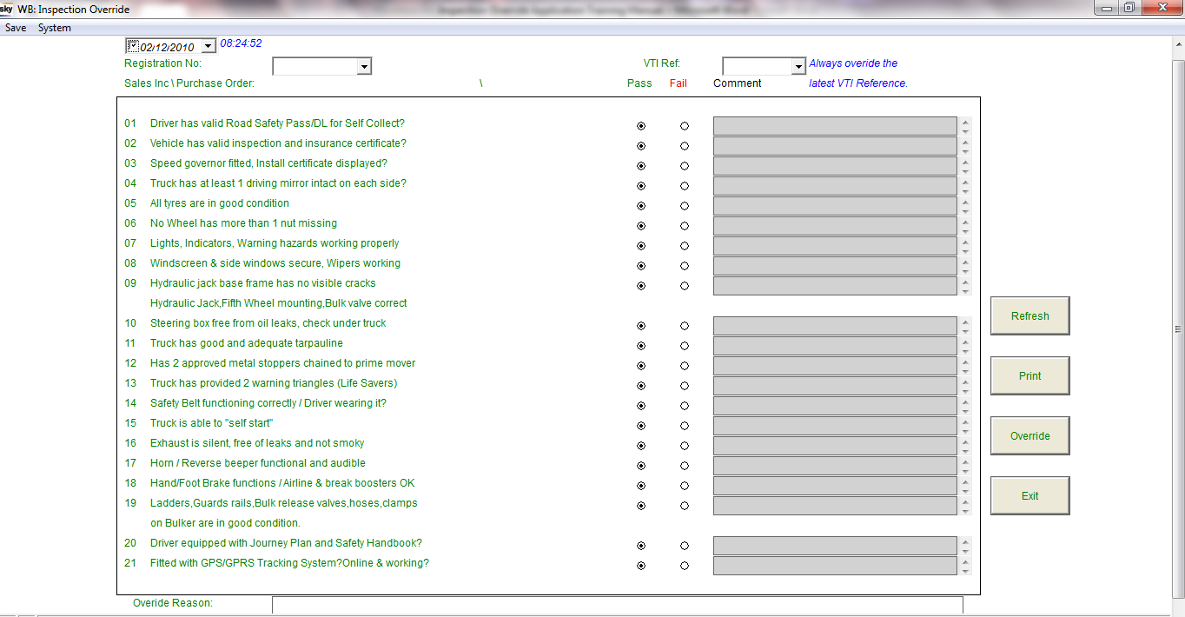

* The user will select the relevant Vehicle’s Registration number from the Reg no drop down box.





* The user will have to select the correct VTI reference for the registration that requires an override. Multiple registrations are possible and it is therefore important to always select the latest registration reference to override.  
  
* The selected Vehicle’s inspection details will be automatically displayed on the screen.

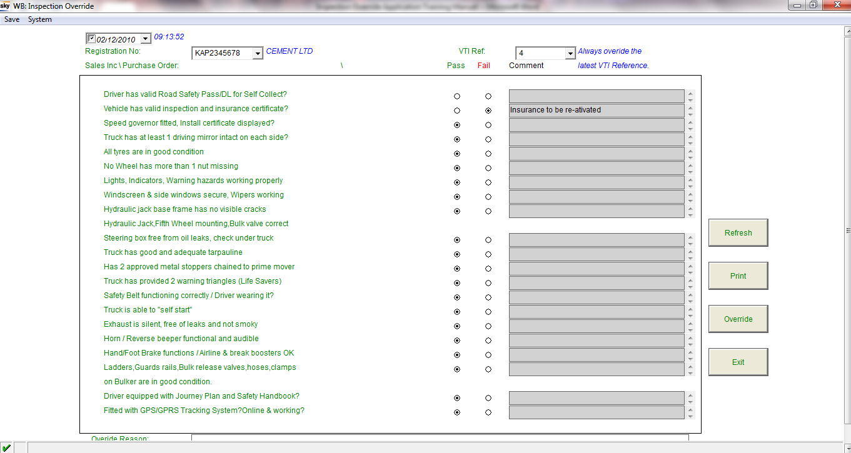

* The Supervisor or Manager will have a look at the Inspection Checklist details and make a decision to either:
* Override the failed inspection and let the truck proceed

OR

* To not override the failed inspection, and send the truck back to repair the part that failed the inspection before it is allowed back in the yard.
* For this example we are going to Override the failed inspection and let the truck proceed.
* The user will enter an Override Reason into the Override reason comment box. – It is mandatory for the user to enter an override reason as the system will not allow the override without a reason entered into the Override reason field.



* Note that if the user wants to print the Failed Inspection Checklist, he will have to do so before doing the Override.
* The report can be printed by clicking on the Print button. 
* The user will click on the  Button.
* A dialogue box will be displayed confirming if you want to override the failed inspection.

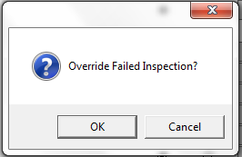

* Click on the  Button.
* The vehicle’s inspection has now been passed and the status of the Vehicle’s Reg no has changed from Failed to Passed, an order can now be assigned to the truck at CSC.

# Customer Service Application Functionality

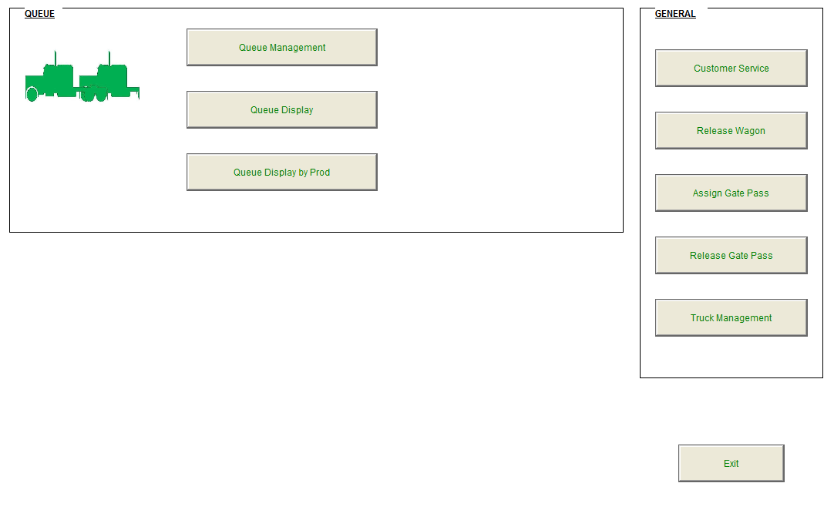

* From the WB Main Menu, click on the  Button.
* The Customer Service Screen will be displayed.

## Customer Services Screen

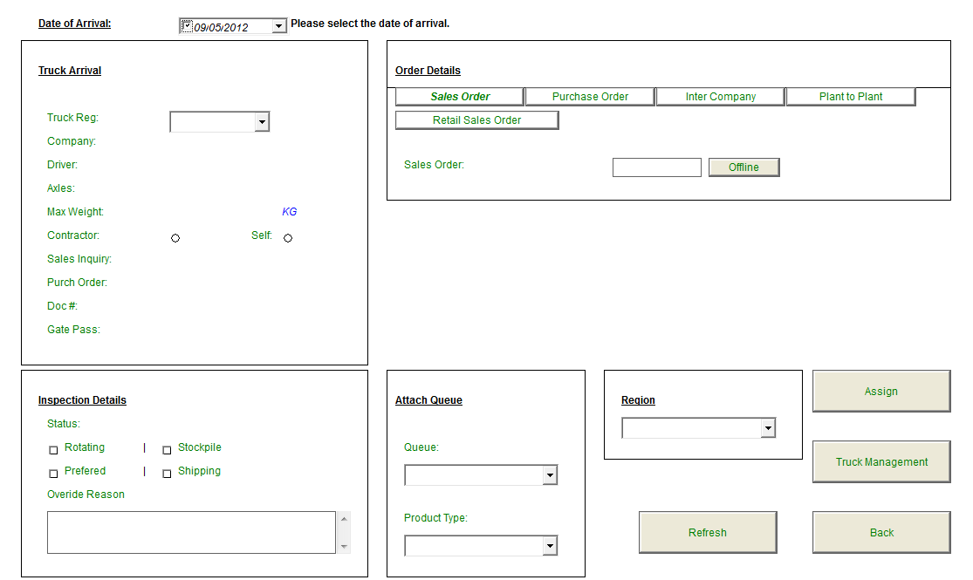

* Note that the Date of Arrival field will always default to today’s date. But if the truck arrived the day before the previous day’s date will have to be selected.



* Select the relevant Truck Reg no from the field.

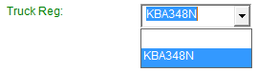

### Truck Arrival Details

* The details captured at Vehicle Arrival will be displayed in the Truck Arrival Block.

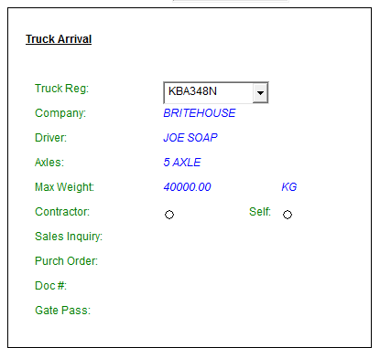

* Note the CSC User needs to select either the Self or Contractor option:
* **Self** – When someone from the Customer’s company is collecting or delivering the Goods.
* **Contractor** – When a contractor is collecting or delivering the goods on behalf of Bamburi.

### Truck Inspection Details

* The Truck’s inspection details will be displayed in the Inspection details block.

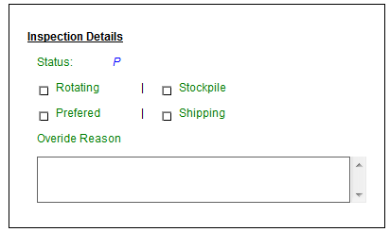

* Note that the relevant status will be displayed in the Status field. If the inspection was Passed, Failed or Overridden.
  + P: Passed
  + F: Failed
  + O: Overridden
    - If the Truck failed its inspection and the supervisor overrides the inspection so that the truck can go ahead the override reason will be displayed in the Override Reason field.
* The Preferred field will be marked with an X if it is a Preferred truck.
* The Shipping field will be marked with an X if it is a Shipment truck.
* The Rotating field will be marked with an X if it is a Rotating Truck.
* The Stockpile field will be marked with an X if it is a Stockpiling Truck

### Order Details

* Note that only 1 Order type can be attached to a truck. In other words you can only attach a Sales Order or a Purchase Order or a Transfer Order or an Inter-company Delivery order or a Retail Sales Order.

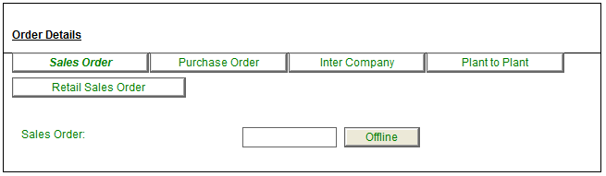

#### **Assigning a Sales Order to a Truck**

#### **If a Sales Inquiry number was selected at Vehicle Arrival then a Sales Order needs to be attached to the Truck Reg.**

Click on the  Tab in the Order Details box to attach a Sales Order.

* Enter the Relevant Sales Order number into the Sales Order field and click on the Enter button on the keyboard.



* A Sales Order matching search screen will be displayed.

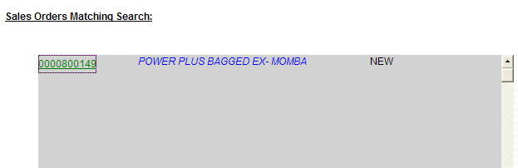

* This screen is there to confirm that the correct sales order with the correct goods for loading are selected.
* Note that the status of the Order is displayed as well. In the example above the status is **New**, this indicates that it is a new order and can be assigned to a truck.
* Note that if the status is **Assigned,** it indicates that the order has already been assigned to a truck and cannot be assigned to another truck again.
* Select the relevant Sales Order number by clicking on the Sales Order number. 
* **Note**: that if the relevant Sales Order number is not displayed in the list, click on the  Button to refresh the list.
* **Note:** If the relevant SO number is still not displayed in the list then it could be that the system is offline and cannot send the newly created orders from SAP. The offline option needs to be used then. Refer to Section 2.2 of this document.
* **For this example the relevant Sales Order can be found in the list.**
* Select the relevant SO number from the Sales Order form the Sales Order Matching Search screen.
* The CSC screen will be displayed, with the Sales Order field completed with the Sales Order number selected by the user.



* User to select the Region, Queue and Product Type form the relevant drop down boxes before clicking on the  button.

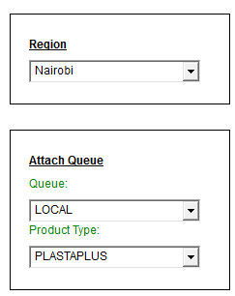

* Click on the  Button to assign the order to the truck.
* A dialogue box will be displayed confirming if you want to assign the order to the truck.

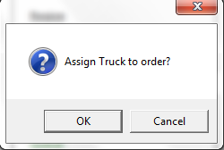

* If you are sure that it is the correct Order number, click on the  Button.
* A dialogue box will be displayed confirming that the Order assignment was successful.

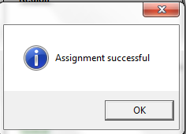

* Click on the  Button.
* The order has now been assigned and the Truck is ready for Weigh 1.

#### **Assigning a Purchase Order to a Truck**

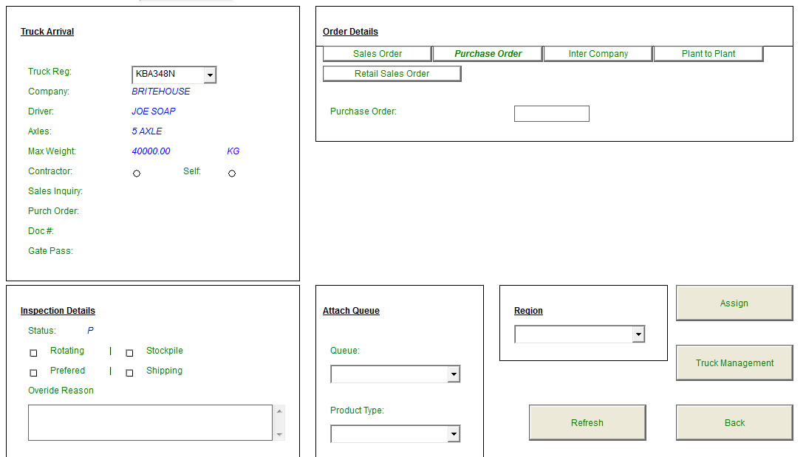

#### **Note that if a Purchase Order number was selected/assigned to the Truck at Vehicle Arrival then the Truck will be able to go straight to the Raw Materials bridge without going to CSC first as the PO has already been assigned.**

* Note that if the Driver did not know what his PO number was and a document number was assigned at Vehicle Arrival, then the Purchase Order number needs to be assigned to the truck at CSC.
* Click on the Purchase Order Tab in the Order details block to attach a Purchase Order to a truck. 

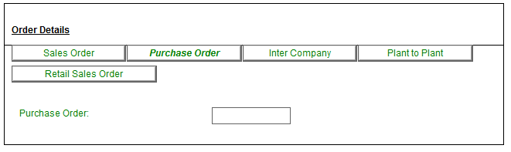

#### Enter the relevant Purchase Order number or a part of the number into the Purchase Order field and click on Enter on the keyboard.



* The Purchase Order Search Match Screen will be displayed displaying all the orders that match the numbers entered into the Purchase Order field by the user.

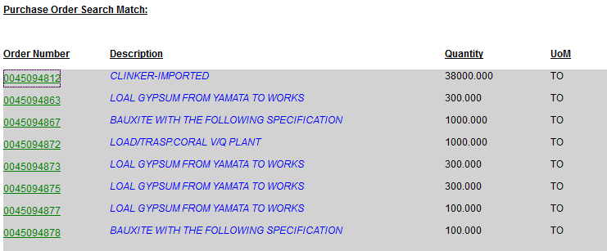

* This screen is there to confirm that the correct purchase order, with the correct product is selected.
* Select the relevant Purchase Order number by clicking on the Purchase Order number. 
* The CSC screen will be displayed, with the Purchase Order number selected in the Purchase Order field.



* **Note:** that if the relevant Purchase Order number is not displayed in the list, click on the  Button to refresh the list.
* If the relevant PO number is still not displayed in the list then it could be that the system is offline and cannot send the newly created orders from SAP. The offline option needs to be used then. Refer to Section 2.2 of this document for the offline Procedure
* User to select the Region, Queue and Product Type form the relevant drop down boxes before clicking on the  button.
* Click on the  Button to assign the relevant PO to the truck.

* A dialogue box will be displayed confirming if you want to assign the order to the truck.



* If you are sure that it is the correct Order number, click on the  Button.
* A dialogue box will be displayed confirming that the Order assignment was successful.



* Click on the  Button.
* The order has now been assigned to the Truck.

#### **Assigning an Inter-Company Delivery Order**

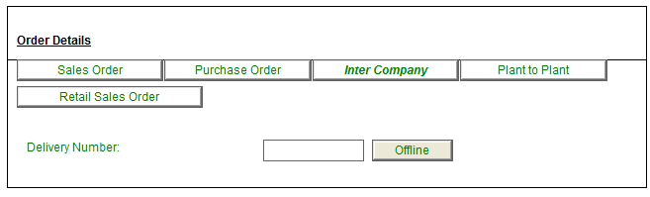

#### **If a Gate Pass number was selected at Vehicle Arrival and the Truck is coming to pick up goods for HIMA then a Delivery needs to be created in SAP by the Logistics team and then attached to the Truck Reg.**

* After the TRUCK has passed Vehicle Inspection the Truck driver will go to the CSC office so that CSC or Logistics can assign the Delivery note number to the truck.
* **Note: When creating Delivery notes for Bulk intercompany orders the following fields must be completed by the user creating the orders before saving:** 
  + **Picked Items location**
  + **Bill of Lading**
  + **Valuation type**
  + **Means of Transport ID**
* **If the above fields are not completed when creating the order then the printing of the Delivery Note through the WIMS system will fail after Weigh 2, as an error will occur in SAP.**
* After the delivery has been created in SAP for the truck, click on the  Button to bring the latest order details into system.
* Click on the Inter Company Tab in the Order Details box to attach a Delivery Number to a truck. 
* Enter the relevant order number into the field and click ENTER on the keyboard.
* The Inter Company Order Matching Search Screen will be displayed, displaying all the orders that matches the numbers entered into the Delivery number field by the user.

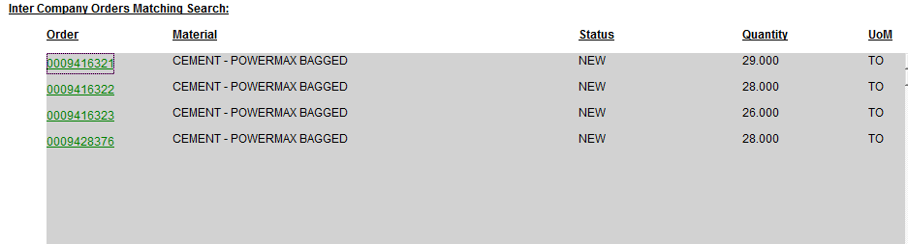

* This screen is there to confirm that the correct Delivery order, with the correct product is selected.
* Select the relevant Delivery Order number by clicking on the Delivery Order number. 
* The CSC screen will be displayed, with the Delivery Order number selected in the Delivery Number field.



* **Note** that if the relevant Delivery number is still not displayed in the list then it could be that the system is offline and cannot send the newly created orders from SAP. The offline option needs to be used then. Refer to Section 2.2 of this document for the offline Procedure.
* User to select the Region, Queue and Product Type form the relevant drop down boxes before clicking on the  button.
* Click on the  Button to assign the relevant Delivery number to the truck.
* A dialogue box will be displayed confirming if you want to assign the order to the truck.



* If you are sure that it is the correct Order number, click on the  Button.
* A dialogue box will be displayed confirming that the Order assignment was successful.



* Click on the  Button.
* The order has now been assigned and the Truck is ready for Weigh 1.

#### **Assigning a Retail Sales Order to a Truck**

#### Click on the Tab in the Order Details box to attach a Sales Order.

* Enter the Relevant Sales Order number into the Sales Order field and click on the Enter button on the keyboard.



* A Sales Order matching search screen will be displayed.

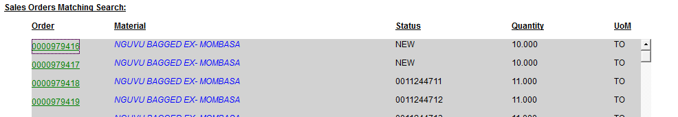

* This screen is there to confirm that the correct sales order with the correct goods for loading are selected.
* Note that the status of the Order is displayed as well. In the example above the status is **New**, this indicates that it is a new order and can be assigned to a truck.
* Note that if the status is **Assigned,** it indicates that the order has already been assigned to a truck and cannot be assigned to another truck again.
* Select the relevant Sales Order number by clicking on the Sales Order number. 
* **Note**: that if the relevant Sales Order number is not displayed in the list, click on the  Button to refresh the list.
* **Note:** If the relevant SO number is still not displayed in the list then it could be that the system is offline and cannot send the newly created orders from SAP. The offline option needs to be used then. Refer to Section 2.2 of this document.
* **For this example the relevant Sales Order can be found in the list.**
* Select the relevant SO number from the Sales Order form the Sales Order Matching Search screen.
* The CSC screen will be displayed, with the Sales Order field completed with the Sales Order number selected by the user.
* 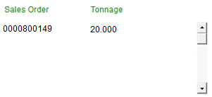The button will allow the user to add the order to the Retail Sales Order list.

Multiple orders may be added in this manner.

* User to select the Region, Queue and Product Type form the relevant drop down boxes before clicking on the button.



* Click on the  Button to assign the order to the truck.
* A dialogue box will be displayed confirming if you want to assign the order to the truck.
* If you are sure that it is the correct Order number, click on the  Button.
* A dialogue box will be displayed confirming that the Order assignment was successful.



* Click on the  Button.
* The order has now been assigned and the Truck is ready for Weigh 1.

#### **Assigning of Stock Transfer Order**

#### 

* If a **Gate Pass number** was selected at Vehicle Arrival and the Truck is transferring goods from Plant to Plant or Plant to Depot then a Transfer Order needs to be attached to the Truck.
* After the Truck has passed inspection the truck driver will go to the CSC office so that the relevant Transfer order can be assigned to the truck.
* Click on the Plant to Plant Tab in the Order Details box to attach a Transfer Order to a truck. 
* Enter the relevant order number into the field and click ENTER on the keyboard.
* The Stock Transfer Order Search Match Screen will be displayed, displaying all the orders that matches the numbers entered into the Transfer Order field by the user.

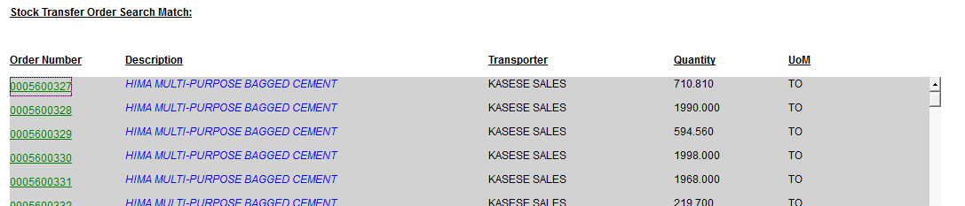

* This screen is there to confirm that the correct Transfer order, with the correct product is selected.
* Select the relevant Transfer Order number by clicking on the relevant Transfer Order number in the list. 
* The CSC screen will be displayed, with the Transfer Order number selected in the Transfer Order field.



* Note: that if the relevant Transfer order number is not displayed in the list, click on the  Button to refresh the list.
* If the relevant Transfer Order number is still not displayed in the list then it could be that the system is offline and cannot send the newly created orders from SAP. The offline option needs to be used then. Refer to Section 2.2 of this document for the offline Procedure
* Note that the Issuing storage location needs to be selected by the CSC Clerk.



* Select the relevant issuing storage location from the Issue Storage drop down box.

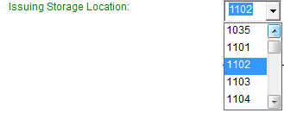

* User to select the Region, Queue and Product Type form the relevant drop down boxes before clicking on the  button.
* Click on the  Button to assign the relevant Transfer Order to the truck.
* A dialogue box will be displayed confirming if you want to assign the order to the truck.



* If you are sure that it is the correct Order number, click on the  Button.
* A dialogue box will be displayed confirming that the Order assignment was successful.



* Click on the  Button.
* The order has now been assigned and the Truck is ready for Weigh 1.

### Region, Queue and Product Selection

* CSC will have to select the Region, Queue and Product Type from the relevant drop down boxes before clicking on the Assign Button.

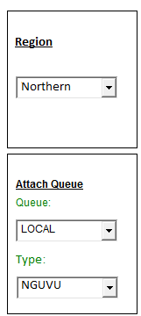

##### Releasing a Gatepass

* Note that if the incorrect Gatepass has been assigned to the truck at Vehicle Arrival, then the CSC Clerk can release the Gatepass from the truck by clicking on the Button when they are on the Plant to Plant order Tab.

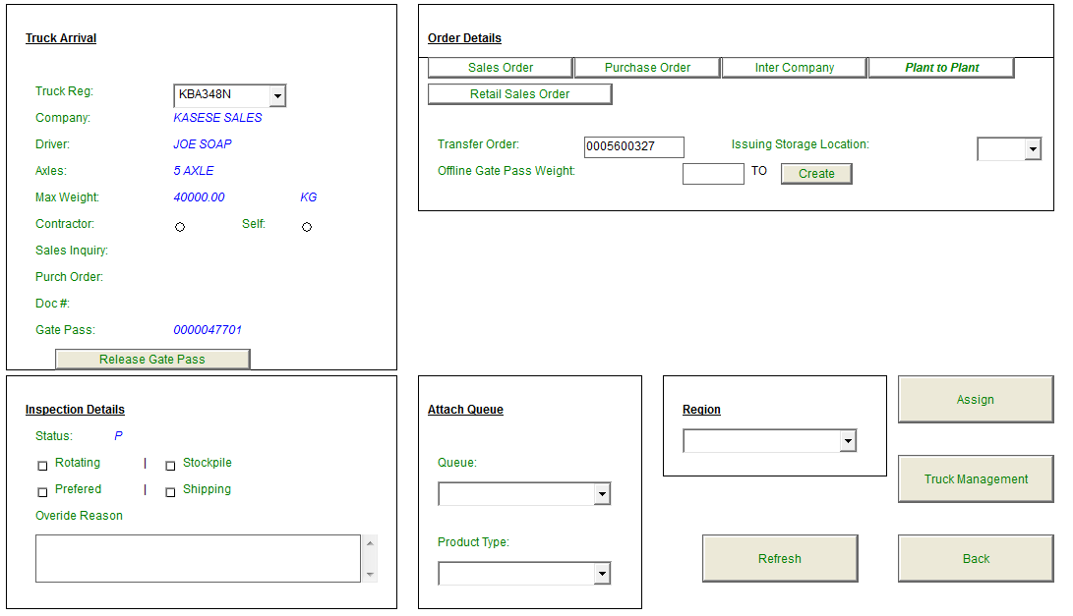

* Note that the  button will only be displayed Plant to Plant menu option as it is only applicable to Stock Transfer orders.
* Click on the button to release the incorrect assigned gatepass from the Truck.
* A message box will be displayed confirming if the user wants to release the gatepass from the truck.

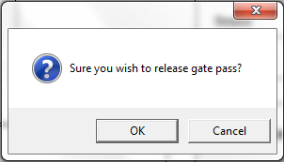

* Click on the OK Button.
* The Gate pass will be released from the truck.

### Truck Management

* From the CSC Screen, click on the  button.
* The Truck Life Cycle View screen will be displayed.

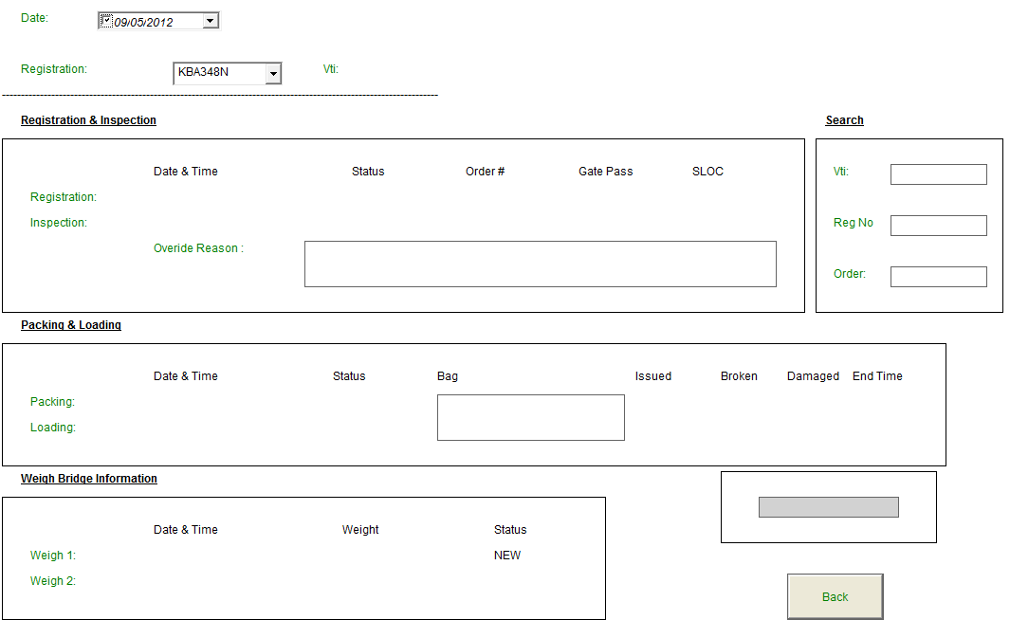

Select the Relevant Truck’s Reg no from the field.

* The Truck’s details will be displayed in the various blocks: Registration and Inspection, Packing and Loading, Weighbridge Information, depending on where the truck is in the plant.

Example:

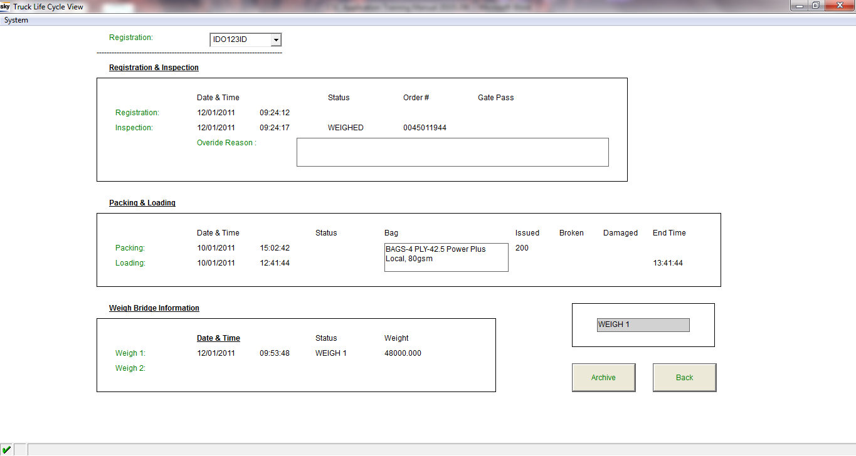

* Note that the above Truck’s current status is 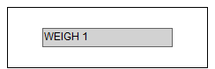. The selected truck’s current status will always be displayed in this field.

## Assigning a Gatepass to a truck

* If a gate pass was not assigned to a truck at Vehicle arrival, then the CSC clerk can assign a gate pass to the truck through the CSC Gate Pass Assignment application.



* From the WB: Main Menu screen the user will click on the  Button.
* The Assign Gate Pass screen will be displayed.

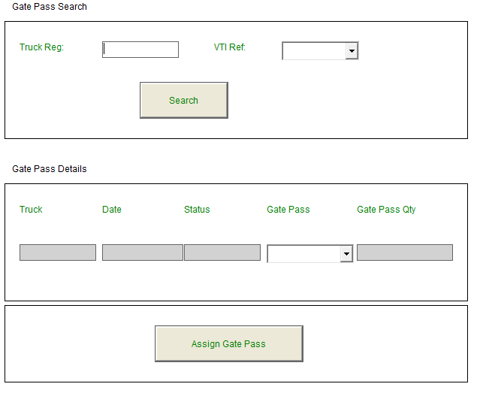

* The CSC Clerk will enter the Truck’s Registration number and Reference number into the relevant fields.

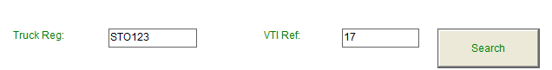

* Click on the  Button.
* The Truck details will be displayed in the Gate pass details block

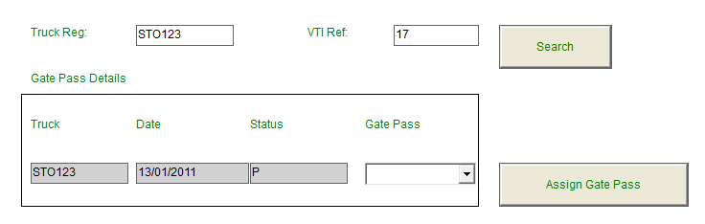

* Select the relevant Gatepass number from the Gatepass dropdown box.

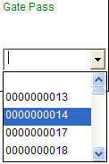

* Click on the  Button.
* A pop up box will be displayed, confirming if the user wants to assign the gatepass to the truck.

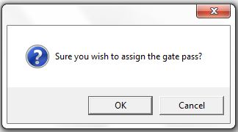

* Click on the  Button to assign the Gatepass to the truck.
* A pop up box will be displayed informing the user that the Gatepass has been assigned to the Truck.

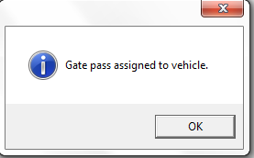

* Click on the  Button.

## Offline Procedure

Procedure to follow when the system is offline:

When the system is offline a red X will appear in the bottom left hand corner of the screen. 

* **NOTE that if the system is OFFLINE** and the user cannot find the specific Sales Order, Intercompany Delivery or Gate pass number in the respective drop down lists, the user will then have to click on the button next to the sales or intercomany delivery order no or offline Gatepass on the Plant to Plant tab to create the offline order/gatepass.

### Creation of Offline Sales Orders

**Example:**

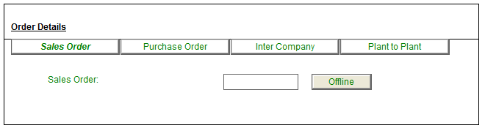

* Click on the  button a dialogue box will be displayed confirming if the user wants to create an offline sales order.

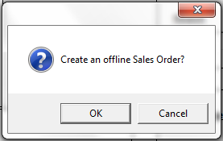

* Click on the  Button.
* The WB Sales Order Offline Screen will be displayed:

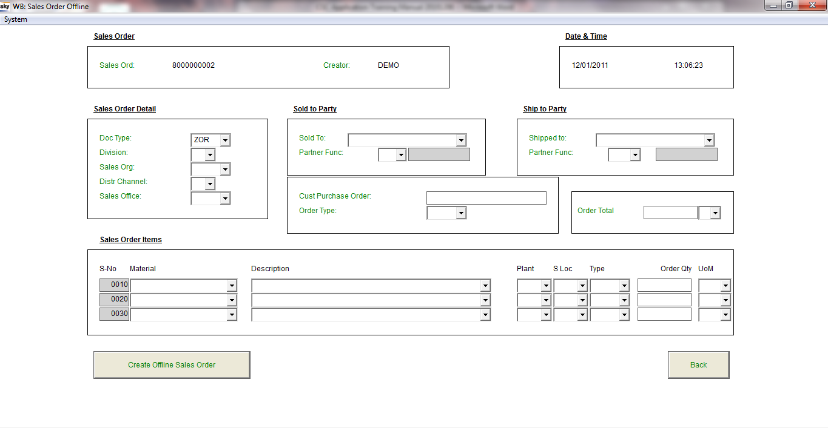

* User to complete all of the above fields to create the offline Sales Order.
* Note that the Offline Sales Order number is automatically generated by the System.

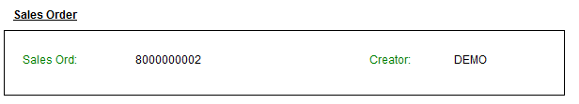

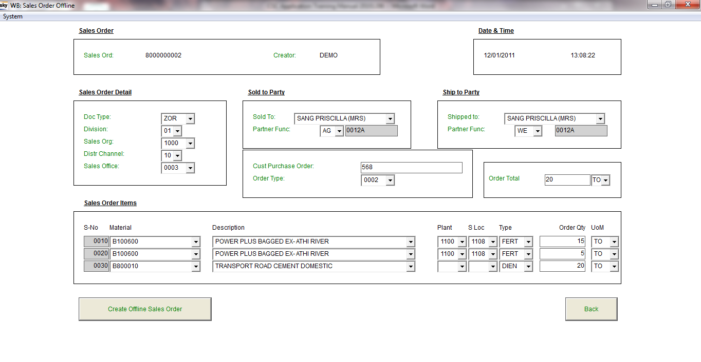

* Note that the line items for the Sales Order are selected and created in the Sales Order Items block:

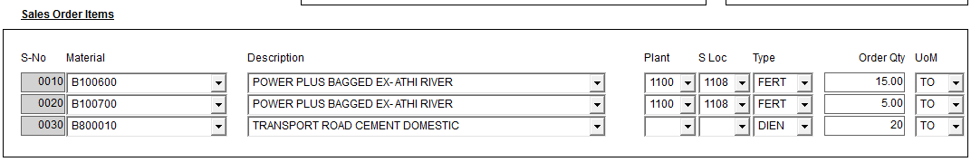

* Note in the above example the Sales Order will have 3 line items, 2 with Product (FERT) and one line item for Transport Cost (DIEN). Note with a DIEN Material a Plant and SLOC should not be selected.
* Click on the  button, when all the information has been provided on the screen, to create the Offline Sales Order.
* A dialogue box will be displayed confirming if the user wants to create an offline Sales Order.

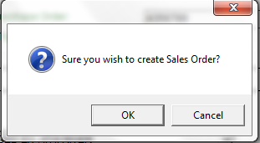

* Click on the OK Button.
* The offline SO number has been created and the CSC Screen will be displayed again.

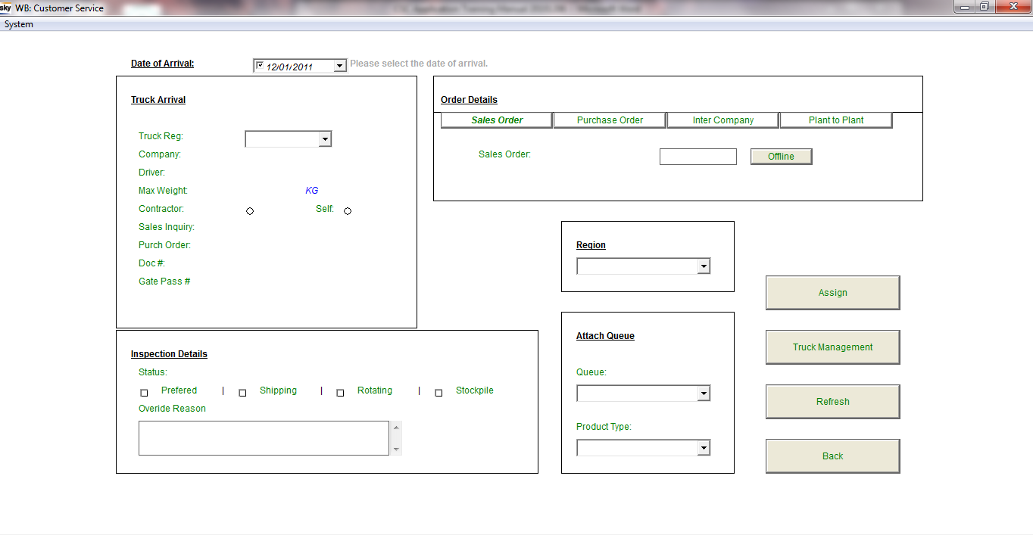

* Assign offline order number 80000002 to the truck.

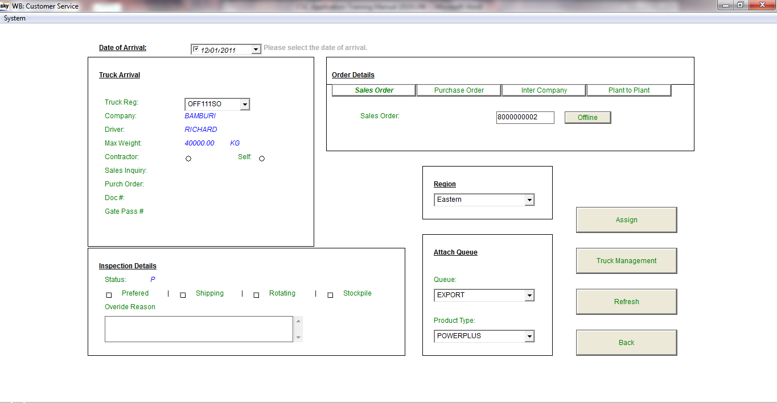

* Complete the required information and click on the Button to assign the order to the Truck.
* A dialogue box will be displayed confirming if you want to assign the order to the truck. 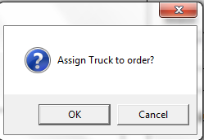
* Click on the  Button. The order has now been assigned and the Truck is ready for Weigh 1.

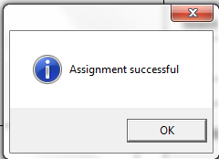

### Creation of Offline Inter Company Order

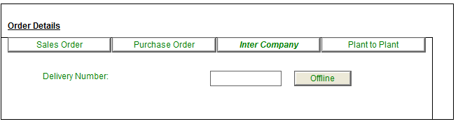

* Click on the  button a dialogue box will be displayed confirming if the user wants to create an offline Purchase order.

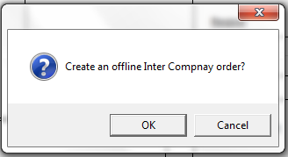

* Click on the  Button.
* The WB Inter Company Offline Screen will be displayed:

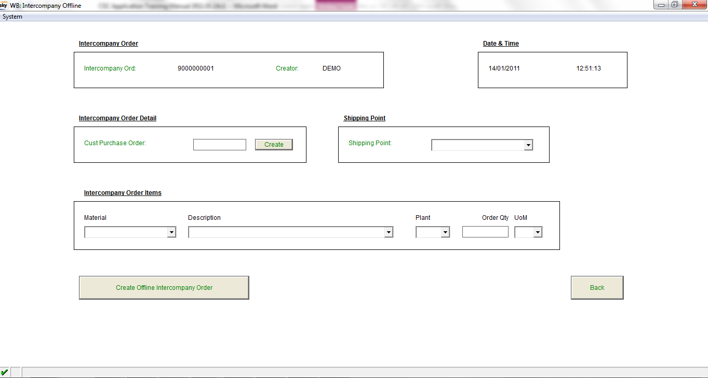

* User to complete all of the above fields to create the offline Inter Company.
* Note that the Offline Inter Company Order number is automatically generated by the System.

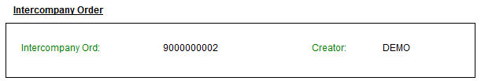

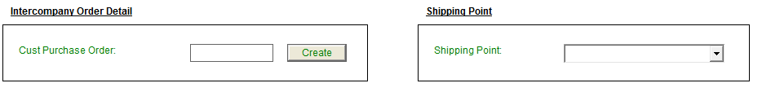

* Enter the SAP Purchase Order number into the Cust Purchase Order field.



* Select the relevant Shipping point from the Shipping point dropdown list.

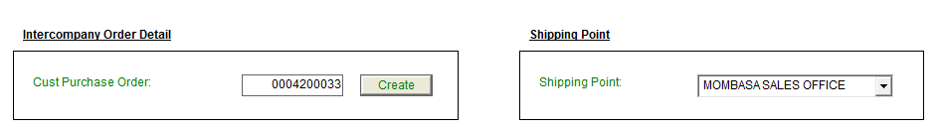

* Note that the line item for the Inter Company Order is selected and created in the Intercompany Order Items block:

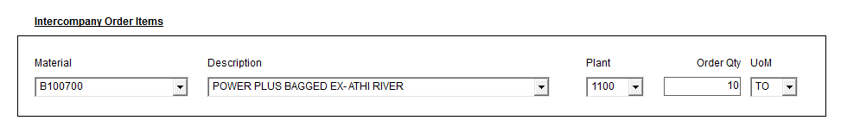

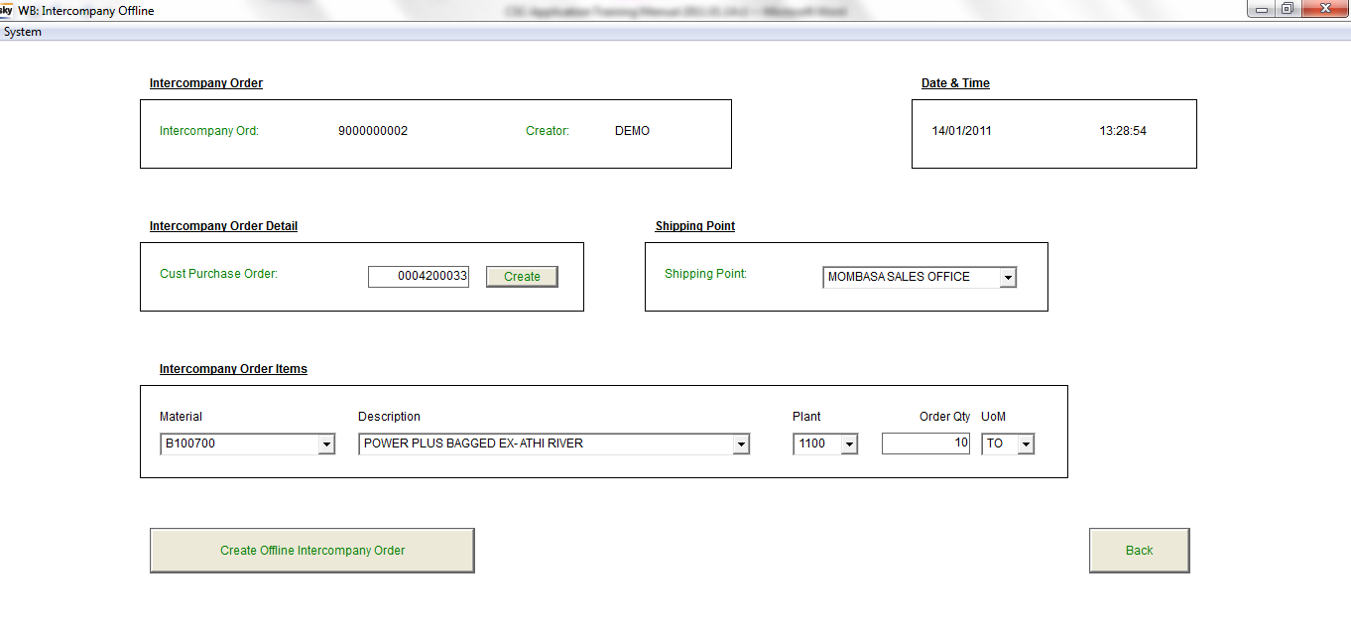

* Click on the  button, when all the information has been provided on the screen, to create the Offline Inter Company Delivery Order.
* A dialogue box will be displayed confirming if the user wants to create an offline Inter Company Order.

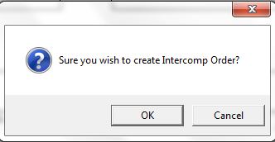

* Click on the OK Button.
* CSC Screen will be displayed again.
* The offline Inter Company Order has been created and is now available in the CSC Application to be assigned to a truck. 
* Assign offline order number 90000002 to the truck.

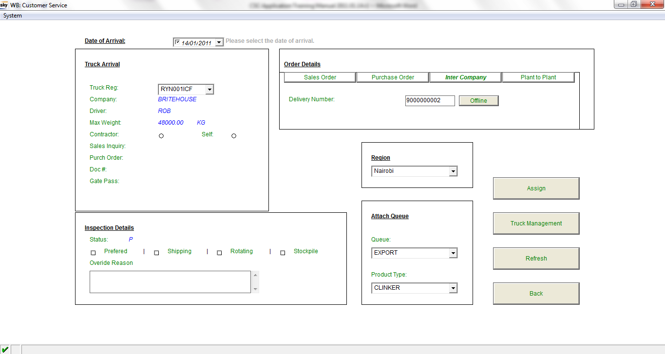

* Complete the required information and click on the Button to assign the order to the Truck.
* A dialogue box will be displayed confirming if you want to assign the order to the truck. 
* Click on the  Button. The order has now been assigned and the Truck is ready for Weigh 1. 

### Creation of an Offline Gatepass

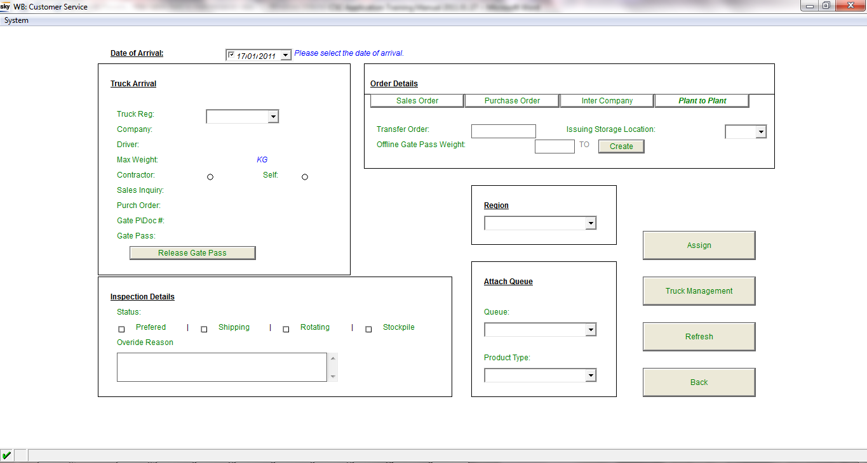

* From the CSC Screen on the Plant to Plant TAB, enter the SAP Transfer Order number into the field and enter the Gatepass Tonnage into the field and click on the button.
* A message box will be displayed, confirming that the Gatepass for the STO order has been created successfully.

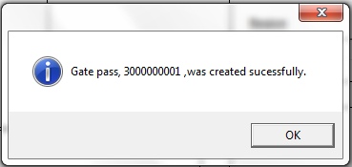

* **NOTE: It is important to write the Offline Gatepass number down when this message is created, in order to know which number to attach to the Truck.**

# Truck Management

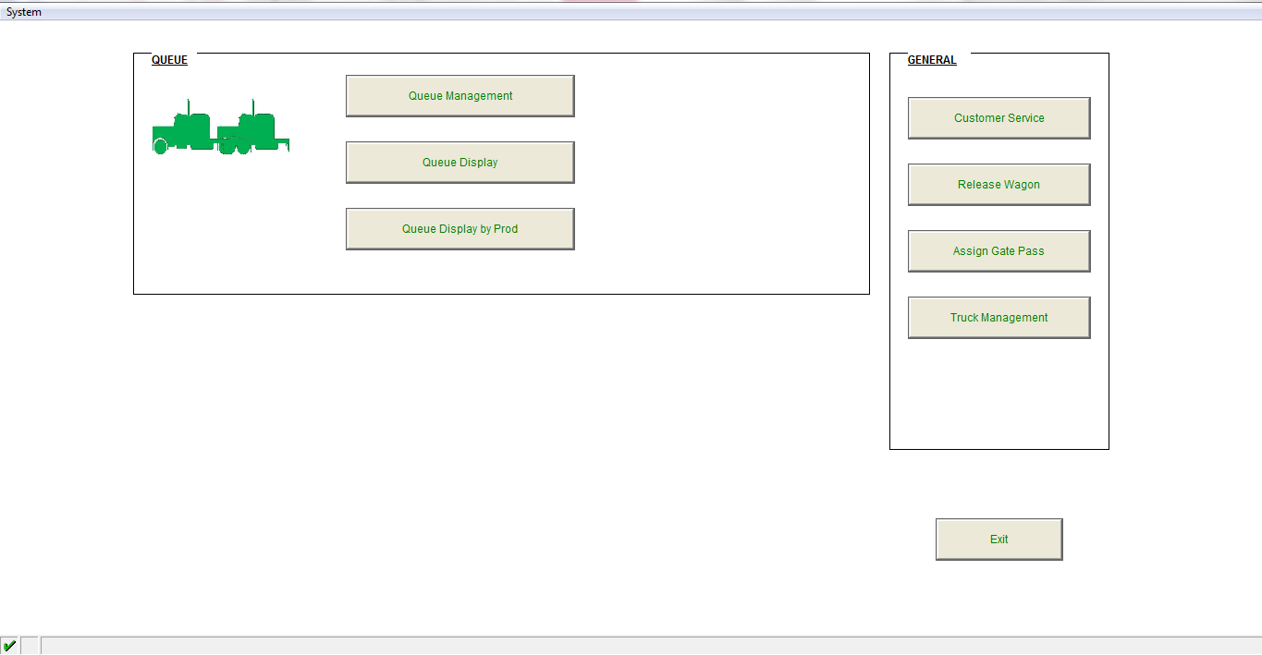

* From the WB Main Menu, click on the  Button.
* The Truck Life Cycle view screen will be displayed

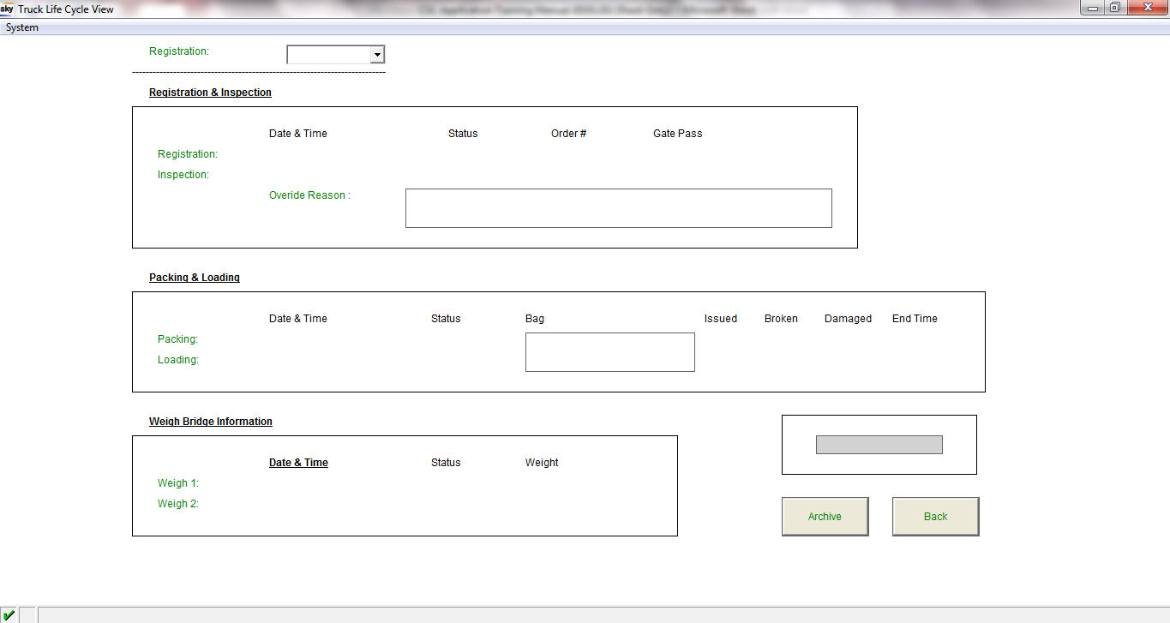

* Select the relevant Truck’s registration number from the drop down box.
* The Truck’s current status will be displayed, as well as the date and time when each status was completed.
* The different Statuses are:
  + Registration
  + Inspection
  + Assigned
  + Weigh 1
  + Packing
  + Loading
  + Weigh 2
  + Completed

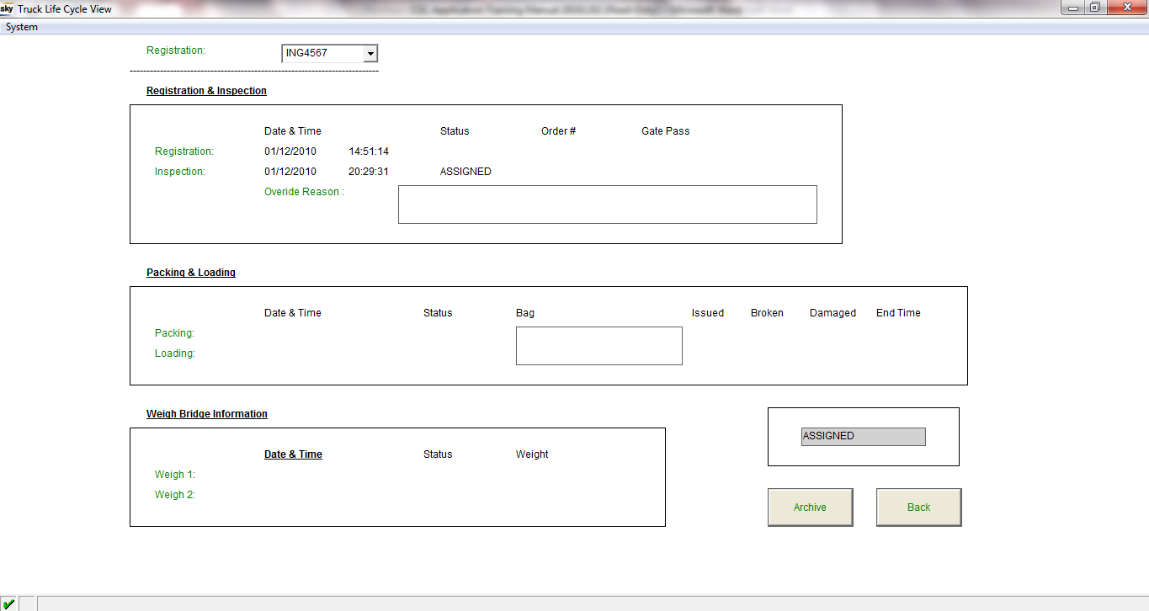

* Note that this field 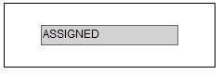 will display the truck’s most recent status in the system.

# Packing Application Functionality

## Packing Screen

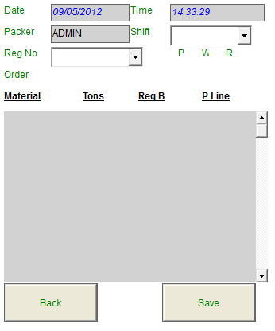

* The Date and Time fields will automatically be defaulted with the current date and time.



* The Packer field will automatically be entered according the User that Logged onto the application.





* The **P** field displays how many times the truck has been packed already.
* The **W** field is for how many times the truck has been weighed.
* The **R** field displays how many times the truck has been rejected.
* The user will select the relevant shift form the Shift drop down box.





* The user will select the relevant Truck Registration from the Truck Reg drop down box.

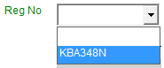

* After the user has selected all the relevant fields the details of the Order will be automatically displayed on the screen as shown below.

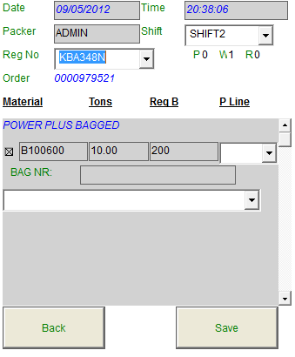

* The user will select the relevant Packing line from the P Line list.

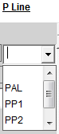

* The user will select the relevant bag used per line item from the Bags dropdown list.



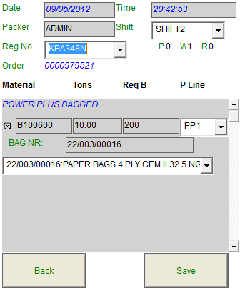

* After all the details have been entered the user will click on the  Button.
* A dialogue box will be displayed confirming if the user wants to save the Packing list.



* Click on the  Button.
* A Packing screen will be displayed, displaying the packing details that was entered and saved.

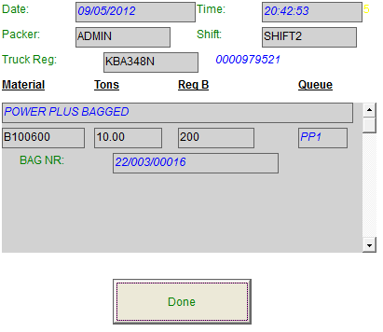

* Click on the  button to complete packing.
* The packing list has now been saved and the goods movements will automatically be done in SAP after Weigh 2 has been completed.
* Note: The Required Bags qty field 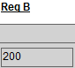 will be used to do the issued bags movement in SAP.
* The screen will now be cleared for the next packing to be done.

# Loading Application Functionality

## Loading Screen

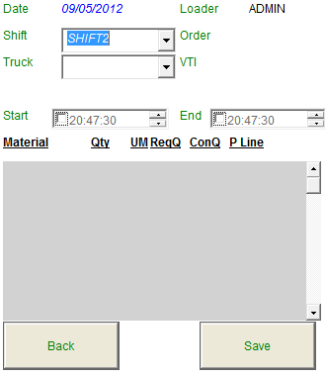

* The Date and Time fields will automatically be defaulted with the current date and time.



* The Loader field will automatically be defaulted according to the User that Logged onto the application.



* The user will select the relevant Shift from the Shift drop down box.

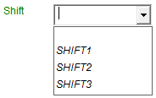

* The user will select the relevant Truck Registration no from the Truck Reg drop down box.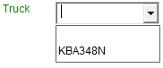
* The user will select the relevant packing line from the P Line Column drop down box.  
    
  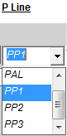

* After the user has selected all the relevant fields the details of the Order will automatically be displayed on the screen as shown on the screen below.

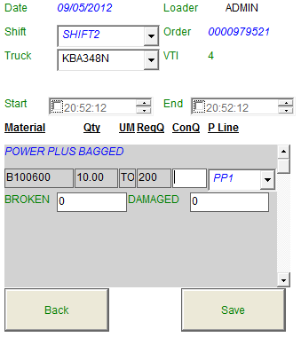

* The truck is now ready for loading.
* To record the Start Load time the user will first select the tick box of the start load field and then enter the relevant time in the Start load field.



* Note that the current time will always be displayed in the time field; the user can still change the time values if it is not correct.
* **How to edit the Start Load time:**



* The field displays **hours, minutes and seconds,** to edit the hours for example you need to click on the hours field (15) and then click on the up or down arrow  to change the hours.
* If you click on the up arrow the time will change from 15 to 16.

.

* The user will have to click on the minutes field to select it and then on the up and down arrows to changes the minutes. The same will apply for the seconds.
* After the loaders have finished loading the truck the user will then enter the correct End load time into the  load field by selecting the End load tick box  and then entering the relevant time. The same procedure as per the Start Load editing needs to be followed to edit the End load time.



* The user now needs to confirm that the correct Product and Quantity was loaded by verifying that the Product name on the Loading screen and the Product loaded onto the truck is the same.

and that the Quantity loaded is correct by entering the number of bags loaded into the 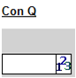 field.

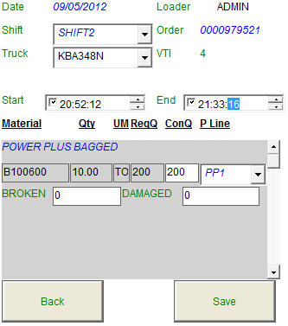

* The user will now enter the number of Broken bags into the  field and the number of Damaged Bags (Factory defects) into the  field.



* After all the details have been entered the user will click on the

 Button.

* A dialogue box will be displayed confirming if the user wants to save the Loading Entry.

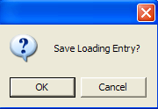

* Click on the  Button.
* The Loading Entry has now been saved and the truck is now ready for its 2nd Weigh.
* **Note**: The Goods Movement for the Broken and Damaged bags in SAP will be done as follows:
* The Broken and Damaged bags qty will be combined and the Goods movement will be processed for the Total qty in SAP.

# Queue Management Application Functionality

* Once CSC has assigned the order and selected the queue the truck will automatically be placed in the queue, selected by CSC, on a first come first serve basis.
* CSC will be able to choose between Exports Queue, Local Queue and Upcountry Queue for Sales Orders. The Truck will be placed in the Queue after CSC has assigned the Sales Order and selected the relevant Queue.
* “NB” Type Purchase Orders will automatically be placed in the **RAW** Queue, on a first come first serve basis, after the relevant purchase order has been assigned to the truck at arrival and the truck has passed inspection.
* “UB” type Purchase Orders (Stock Transfer Orders) will be automatically assigned to the relevant queue, according to the order’s Material Type, after CSC has assigned the relevant Stock Transfer Order number to the Truck.

**Stock Transfer Orders with material type:**

* FERT – Will be placed in the Transfer Queue on first come first serve basis.
* ROH – Will be placed in the Raw Queue on first come first serve.
* HALB – Will be placed in the Raw Queue on first come first serve.
* CLK – Will be placed in the Raw Queue on first come first serve.
* Inter Company Order will automatically be placed in the **Export queue**, on a first come first serve basis, after CSC has assigned the relevant Inter Company Delivery note number to the truck.
* CSC will have the ability to move priority trucks up in the queue, through the queue management application if required.
* If the wrong queue has been assigned to the Sales Order by CSC, the following Queue reallocation process needs to be followed: The CSC user will delete the truck from the queue. The truck will then be released from the order and queue. The user then needs to reassign the same truck to the relevant order and select the correct queue.

## Queue Management Screen

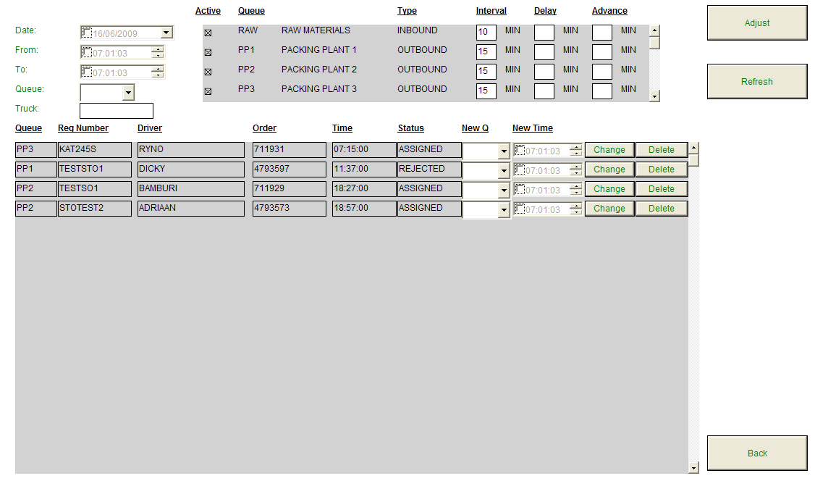

* The Trucks will be placed into the queue according to the following procedures:
  + “NB” Type Purchase Orders will **automatically** be placed in the **RAW** Queue, on a first come first serve basis, after the relevant purchase order has been assigned to the truck at arrival and the truck has passed inspection.
  + Note that the above will only be applicable when the Inbound side goes live in MSA.
  + **ZOR, ZEX, ZIC and UB type** Sales Orders, Intercompany Transfer Orders and Stock Transfer Orders for all Material types will be assigned to the relevant Queue according to the criteria selected by the CSC Clerk on the CSC Application.
  + **Selection Criteria on the CSC Screen:**
    - **Queue**: Local, Upcountry, Export, Transfer
    - **Product** **Type**: Nguvu, Powerplus, Powermax, Plastaplus, Clinker, Multipurpose.
    - **Example**:
      * If **Local** Queue and **Nguvu** Product Type are selected by CSC, then the truck will be placed in the **Nguvu-Local Queue.**

# Weighbridge Outbound & Inbound Side Application Functionality

* Processes currently supported through Outbound side:
* Sales Orders – Bagged & Bulk (ZEX, ZOR, ZFD)
* Inter Company Transfer Orders – Bagged (ZIC)
* 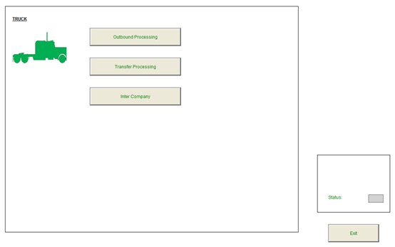Stock Transfer Orders – Bagged & Bulk (UB)
* The WB Main Menu is divided into 2 blocks, each with different options:
* **Truck Block**:
  + Outbound Processing – Dispatch of Sales Orders
  + Transfer Processing – Goods Issue and Receipt of Stock Transfer Orders
  + Inter Company – Dispatch of Inter Company Orders
* **Status Block:** To the display the connection status of the Comport for the Weighbridge station.

## Navigating to the correct WB order screen

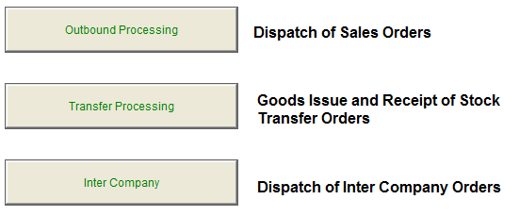

* Click on the Outbound Processing Button.
* The Truck Outbound Screen will be displayed.

## Truck Outbound Processing

### Dispatch of Sales Orders

* For this example we have registered a Truck at Vehicle Arrival with Reg no: KBA348N, it has passed the Vehicle inspection process and a Sales Order no 0000979521 has been assigned to the truck at CSC.



* Click on the  Button located on the WB: Main Menu Screen or navigate directly to the screen through the quick navigation option.
* The WB: Truck Outbound Screen will be displayed.

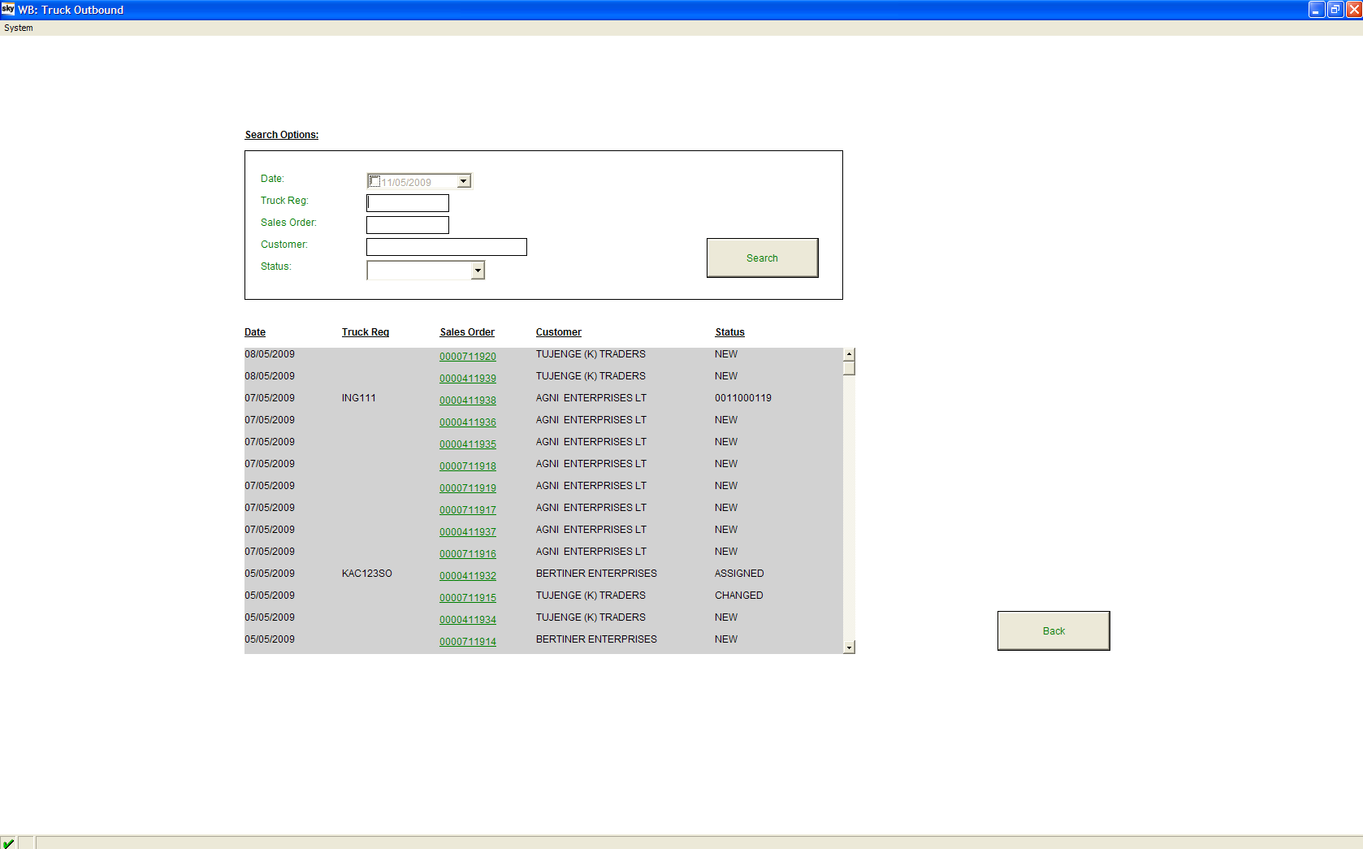

* Note that the Status for the Truck Reg no KBA348N is ASSIGNED.





* Note that if the Status is ASSIGNED it means that the Sales Order has been attached to the truck at CSC.
* If the Status is FAILED, it means that the Vehicle has gone through the Vehicle Arrival and Inspection Process, but has Failed the inspection process and therefore cannot proceed until inspection is passed/overrided by the Supervisor.

Click on the green Sales Order number next to the Relevant Reg no:





* The WB: Capture Screen will be displayed.

WB: Capture Screen – (Weigh 1 to be done)

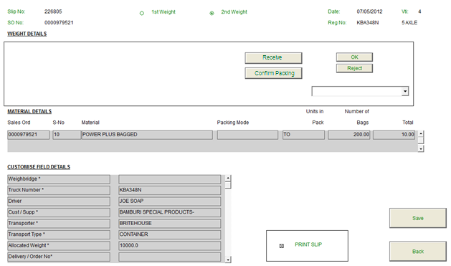

* Note that the Sales Order number, Slip no, and Date will automatically be displayed.
* The Weight 1 Radio Button or Weight 2 Radio Button fields will also be automatically selected. In this example the Truck will be on Weigh 1 Radio Button because it is going for its first weight.
* The screen will not be able to capture a weight from the bridge due to no bridge being available. The truck therefore needs to be received for packing and this will serve the same purpose as weighing the truck for the first time.
* Click on the Receive button to receive the truck for packing.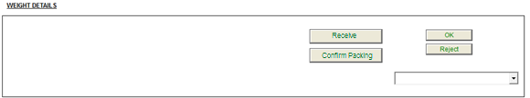
* The WB: Truck Outbound screen will then be displayed again.

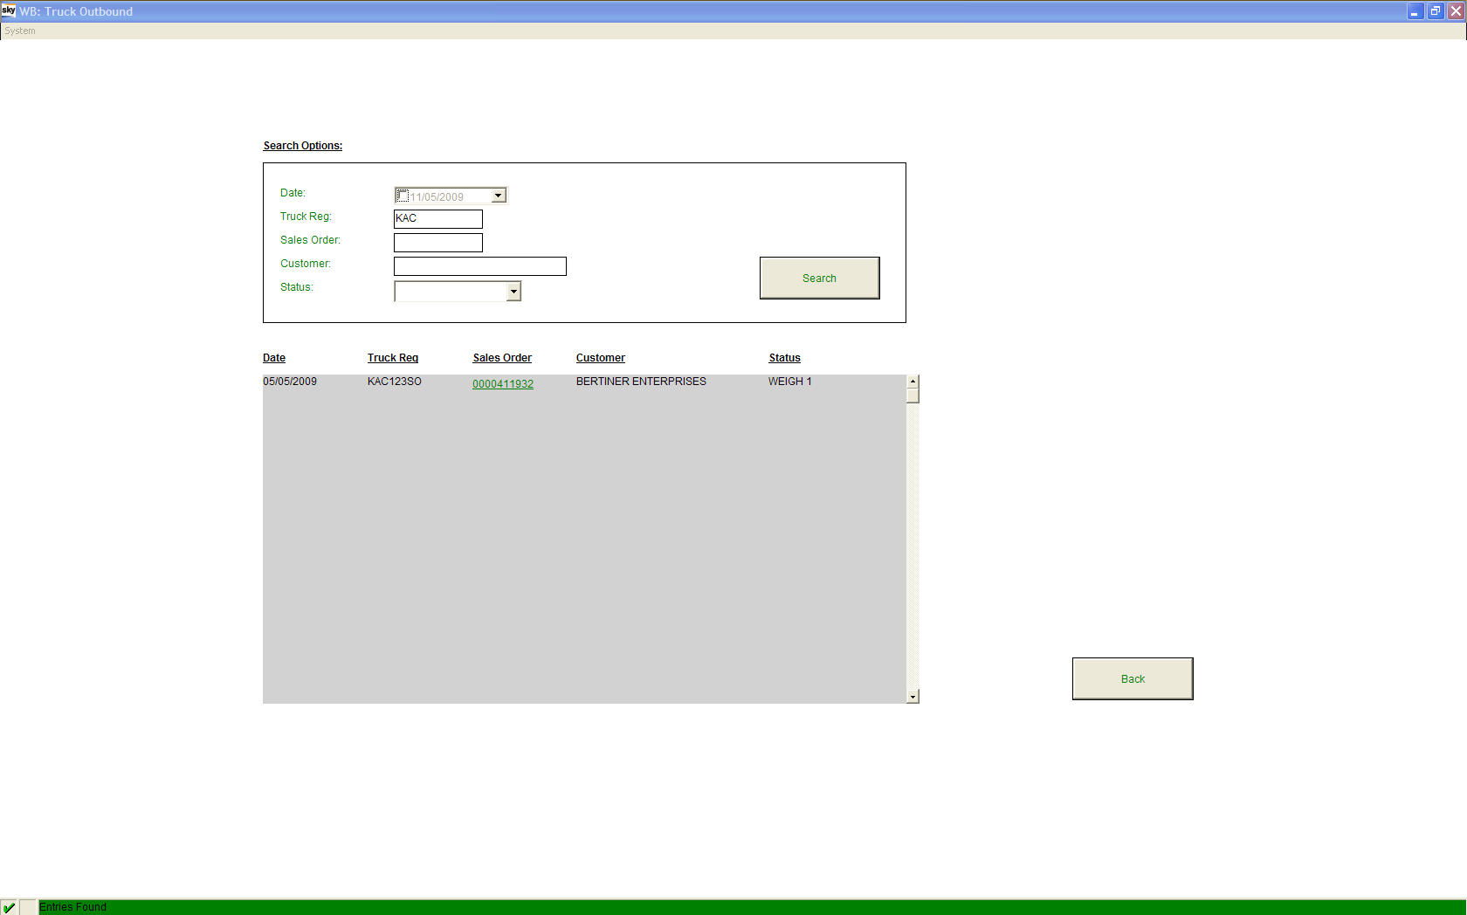

* Note that the Status of the Vehicle with Reg no KBA348N has changed to WEIGH 1, which means that the Vehicle has completed its 1st Weigh and is now ready for Packing & Loading.
* After the “Packing & Loading” has been completed; Weigh 2 can be taken.





* Click on the green Sales Order number next to the relevant Reg no if the Vehicle is ready for its Second Weigh.
* The WB Capture Screen will be displayed.

WB: Capture Screen – (Weigh 2 to be taken)

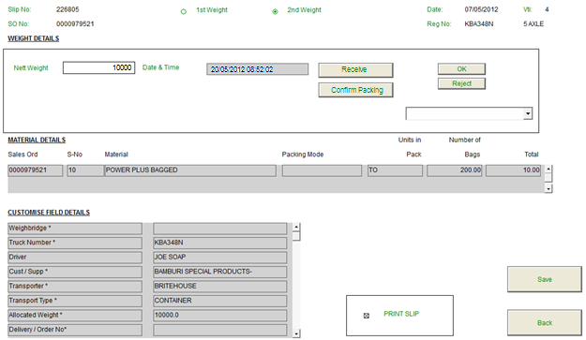

* Note that the Sales Order number, Slip no, and Date will automatically be displayed.
* The Weight 1 or Weight 2 fields will also be automatically selected; Weight 1 has been done so Weight 2 will be selected now.
* At this point the user will indicate what the Nett Weight is for the order.
* The user will then click on the Confirm button to validate the Nett weight against the Order weight and the packing done for the truck.



**Note**: The order validation will still include validation on the tolerances to allow for differences in the Nett Weight.

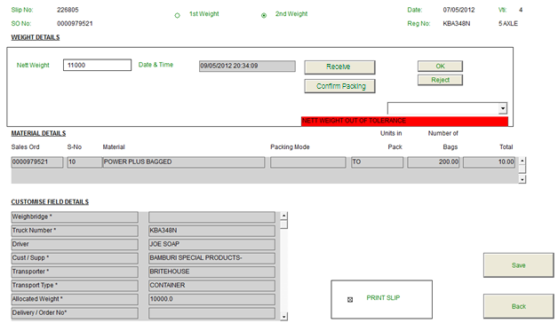

* Note that the truck’s Nett Weight is out of tolerance in the above example and needs to be corrected.
* The user may reject this in order to request a repacking of the truck.

### Rejecting a load

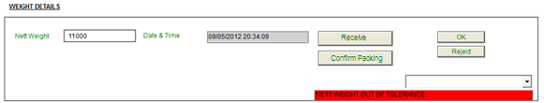

* If a nett weight is rejected, a rejection slip will print out and the truck will be sent back to the Loading plant for offloading and checking of Cement bags.
* The user will have to recapture the net weight in order to allow the truck to be processed to completion.
* Select a rejection reason from the drop down box.



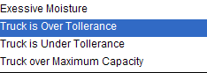

* Click on the  Button.
* The rejection slip will print out and the truck will be sent to the Loading plant for offloading and re-loading.

#### Example of a Rejection slip:

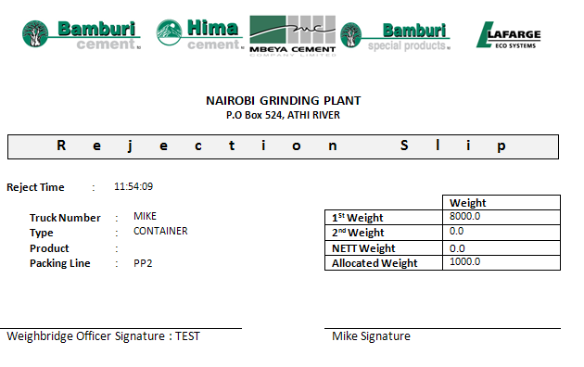

* The WB Main Menu will be displayed.
* Click on the  Button located in the Truck block on the WB: Main Menu screen.
* The WB: Truck Outbound screen will be displayed.
* Note that the status of the Vehicle Reg no KBA348N has changed to Rejected.





* Click on the Sales Order no next to the relevant Reg no.
* The WB: Capture screen will be displayed.



* Note that the Sales Order number, Slip no, and Date will automatically be displayed.

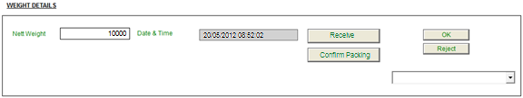

* The Nett Weight of the Truck can now be taken
* Click on the Confirm Packing Button to confirm the Nett Weight reading.



* Note that the Nett Weight has been recorded.
* Click on the  Button to save the order and print the slip (Weighbridge Ticket).
* The WB Main Menu screen will be displayed.
* Note that if you go back to the Truck Outbound screen the order status has changed to COMPLETE.



### Truck Outbound Transfer Orders

* For this example we have registered a Truck at Vehicle Arrival with Reg no: STO6789 with Gate Pass number 20, it has passed the Vehicle inspection process and a Stock Transfer Order number: 0005600007 has been assigned to the truck by CSC.



* Click on the  Button located on the WB: Main Menu Screen or navigate directly to the screen through the quick navigation option.
* The WB: Transfer Processing Screen will be displayed.

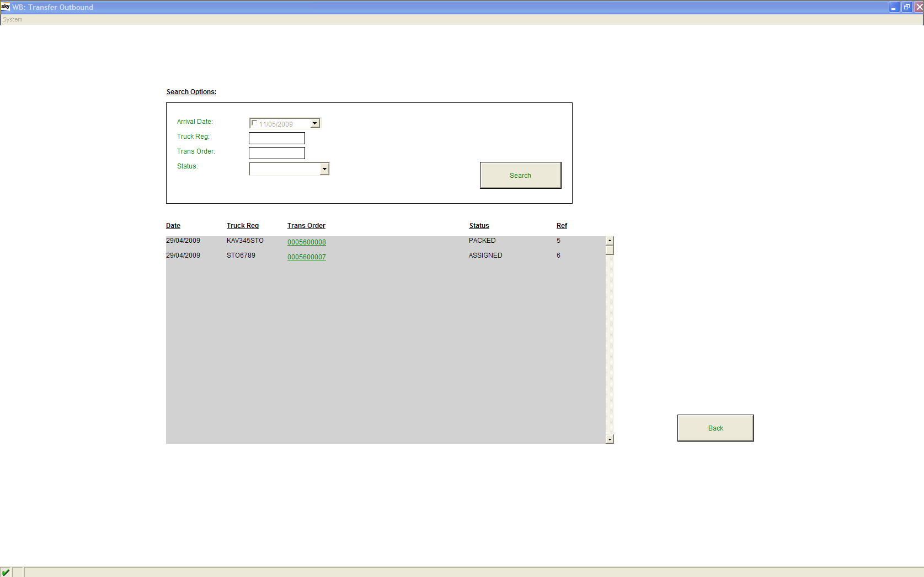

* Note that the Status for the Truck Reg no STO6789 is ASSIGNED.
* Click on the green Sales Order number next to the Relevant Reg no:





* The WB: Capture Screen will be displayed.

WB: Capture Screen – (Weigh 1 to be done)

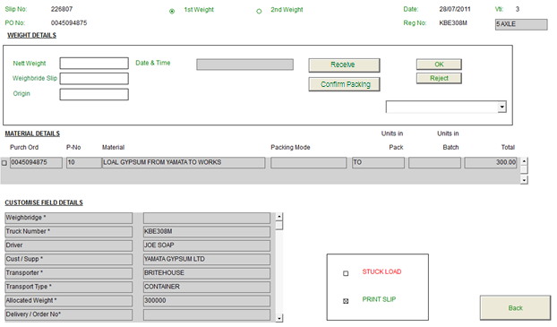

* Note that the Purchase Order number, Slip no, and Date will automatically be displayed.
* The Weight 1 or Weight 2 fields will also be automatically selected. In this example the Truck will be on Weight1 because it is going for its first weight.
* The truck will be processed in very much a similar manner as the Sales Order process. The truck will be received for in order to acknowledge that the truck is commencing the process of either offloading or loading of the order Assigned to it.
* The user will click on the Receive button to receive the truck for processing, this will prepare it for the packing plant.
* The WB: Truck Outbound Transfer screen will then be displayed again after clicking on the receive button.

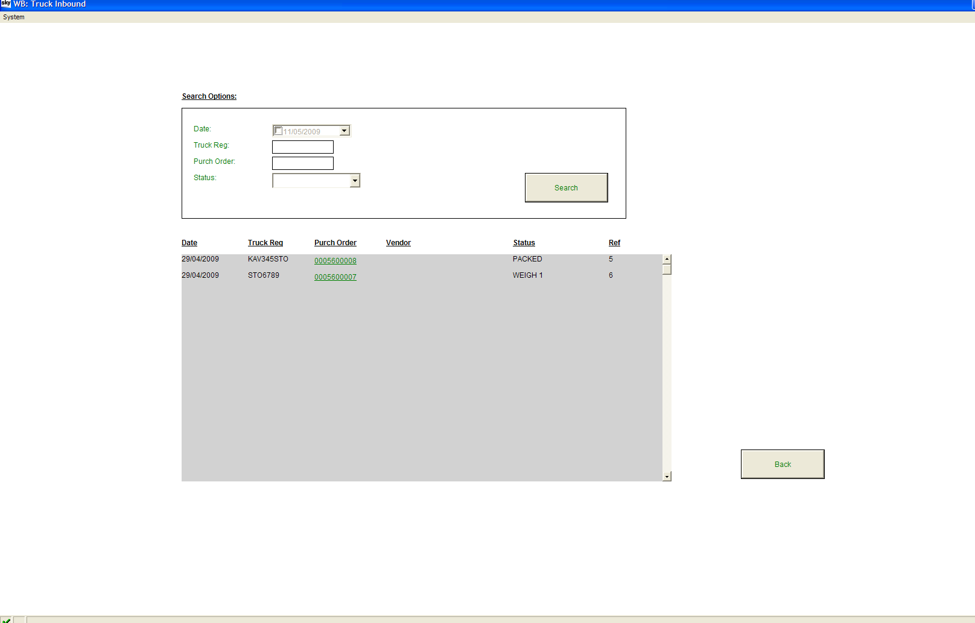

* Note that the Status of the Vehicle with Reg no KAV345STO has changed to WEIGH 1, which means that the Vehicle has completed its 1st Weigh and is now ready for Packing and Loading.
* After the Packing and Loading has been completed; Weight 2 can be taken.



* Click on the green Purchase Order number next to the relevant Reg no if the Vehicle is ready for its Second Weigh.
* The WB Capture Screen will be displayed.

WB Capture screen (Weigh 2 to be done)

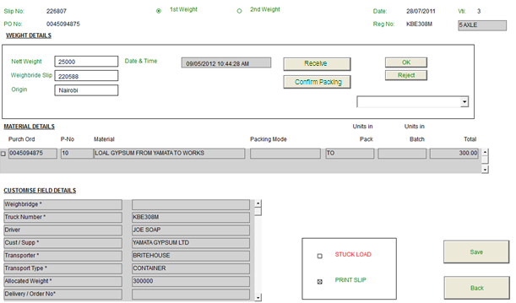

* Note that the Purchase Order number, Slip no, and Date will automatically be displayed.
* 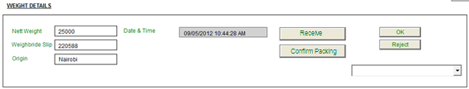The Weight 1 or Weight 2 fields will also be automatically selected; Weight 1 has been done so Weight 2 will be selected now.
* The user will now be required to capture the Nett Weight as indicated by the order or gate pass. The user will also be required to indicate the weighbridge slip number and the origin from where the truck came from during the return of the truck. This will allow the system to compare what was sent has been received by correlating the weighbridge ticket’s net weight as it was loaded at the origin.



* Click on the  Button to save the order and print the slip (Weighbridge Ticket) and Goods Issue note.
* The WB Main Menu screen will be displayed.
* If the User navigates back to the Outbound Transfer screen the status of the order will now be COMPLETE.

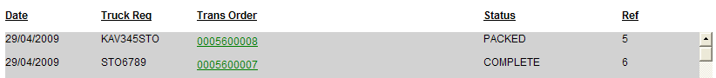

### Inter – Company Transfer Orders



* For this example we have registered a Truck at Vehicle Arrival with Reg no: IC89DEL it has passed the Vehicle inspection process and a Delivery Order number: 0009400020 has been assigned to the truck by CSC.
* Click on the  Button located on the WB: Main Menu Screen or navigate directly to the screen through the quick navigation option.
* The WB: Inter Company Screen will be displayed.

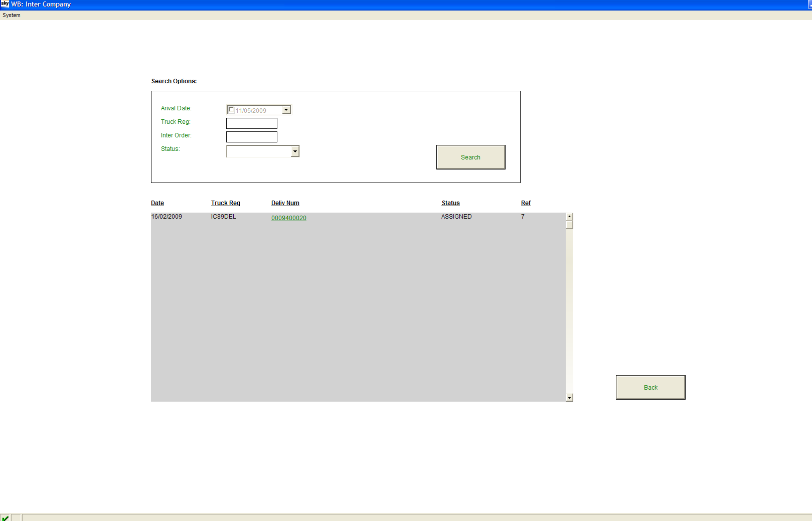

* Note that the Status for the Truck Reg no STO6789 is ASSIGNED.
* Click on the green order number next to the Relevant Reg no:



* The WB: Capture Screen will be displayed.

WB: Capture Screen – (Weigh 1 to be done)

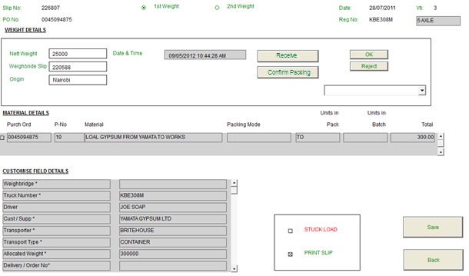

* Note that the Delivery Order number, Slip no, and Date will automatically be displayed.
* The Weight 1 or Weight 2 fields will also be automatically selected. In this example the Truck will be on Weight1 because it is going for its first weight.
* The inter company transfer process will work in very much a similar process as the transfer process, with the only difference being that it is a different order type.
* The truck needs to be received so as to allow for processing at the packing plant or for offloading.
* Click on the receive button to receive the truck.
* The WB: Inter Company screen will then be displayed again.

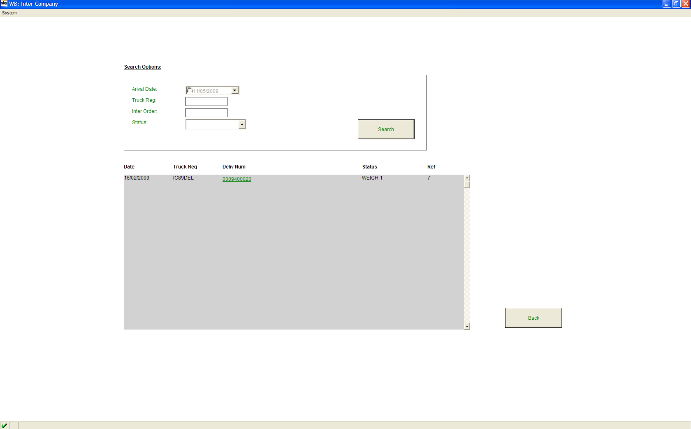

* Note that the Status of the Vehicle with Reg no IC89DEL has changed to WEIGH 1, which means that the Vehicle has completed its 1st Weigh and is now ready for Packing and Loading.
* After the Packing and Loading has been completed; Weight 2 can be taken.
* Click on the green order number next to the relevant Reg no if the Vehicle is ready for its Second Weigh.
* The WB Capture Screen will be displayed.

WB Capture screen (Weigh 2 to be done)



* Note that the Delivery Order number, Slip no, and Date will automatically be displayed.
* The Weight 1 or Weight 2 fields will also be automatically selected; Weight 1 has been done so Weight 2 will be selected now.

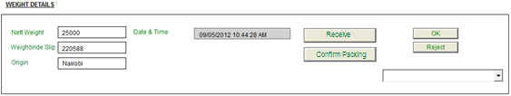

* The user will now be required to capture the Nett Weight as indicated by the order or gate pass. The user will also be required to indicate the weighbridge slip number and the origin from where the truck came from during the return of the truck. This will allow the system to compare what was sent has been received by correlating the weighbridge ticket’s net weight as it was loaded at the origin.

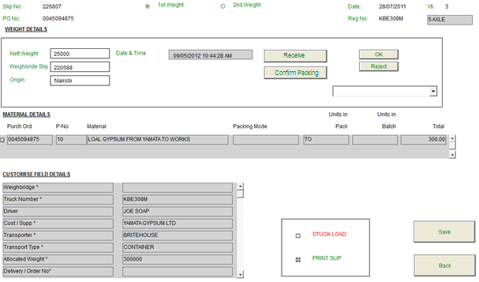

* Click on the  Button to save the order and print the slip (Weighbridge Ticket) and Delivery note.
* Note that the Delivery Note will only print if it is a Bulk Intercompany Transfer Order.
* CSC prints the Delivery note beforehand to use as a Loading document if it is a Bagged Intercompany Transfer Order.
* The WB Main Menu screen will be displayed.
* If the User navigates back to the Outbound Transfer screen the status of the order will now be COMPLETE.



## Notes

# Security Application

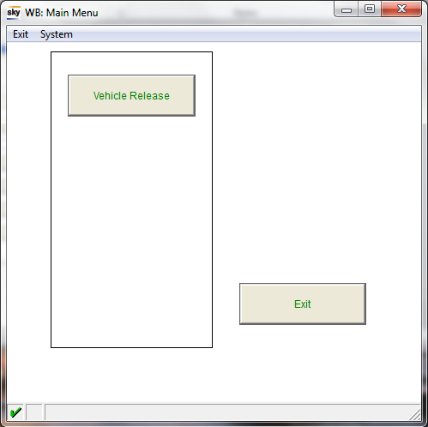

* Click on the  Button.
* The Exit Control screen will be displayed.

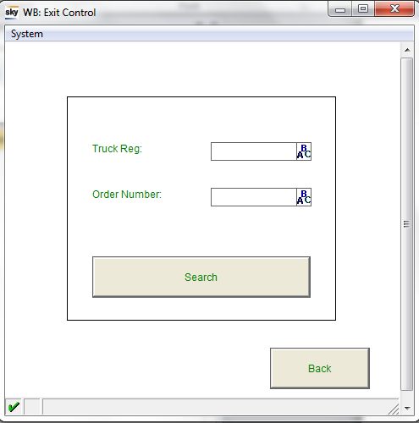

* Search for the Truck to be released by entering the Truck Registration into the field AND/OR entering the order number attached to the truck into the field.
* Click on the button.
* The Vehicle List Screen will be displayed:

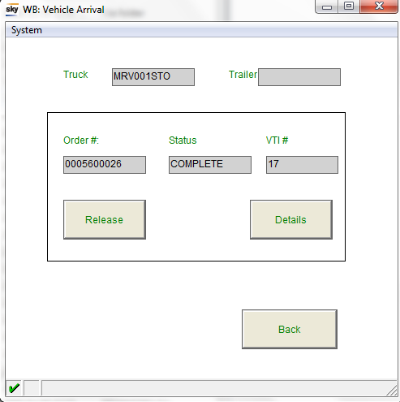

* Note that the truck’s Order number, status and VTI Reference number will displayed on the screen.

## Viewing the truck’s details

* If the security clerk clicks on the  Button, more details of the truck, as captured at vehicle arrival, will be displayed on the screen.

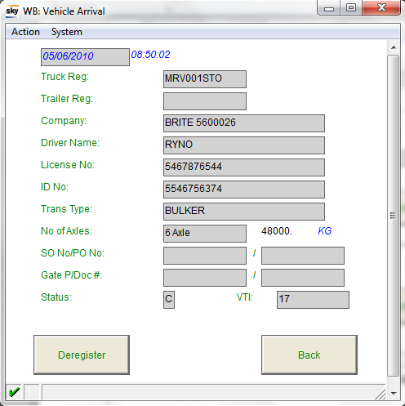

## De-registering of a Truck



* The user can click on the  button on the Vehicle Detail screen, to de-register the truck and archive the registration.
* Note that the De-register will function as a rejection and release of the order from that truck.
* Note that when the truck comes back it needs to be registered afresh.

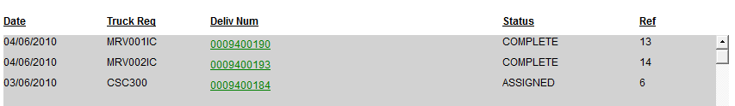

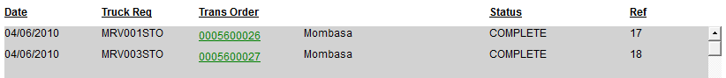

## Releasing of a Truck



* Security Clerk can click on the button if he wants to allow the truck to leave the plant.
* Note that the  Button will only be displayed if the truck’s status is “Complete.”

# Pre-requisite for Mbaraki Plant Implementation & Go-live

* Bamburi to supply Bulk material codes and issuing slocs for Mbabarki.
* KernelPro licenses to be purchased before Go-live.

# Project Risks

## Changes to WIMS App

* Changes made to the tables to include the changes as requested in this document will affect all the plants. All plants will have to stop operations before Go-live of the planned changes.
* Process to be tested thoroughly in QAS before GO-LIVE.
* Process to be followed when plants are moved over to new App:
  + Plant to stop operations.
  + SAP Database updated with latest data- Back up
  + WIMS Server to be stopped
  + WIMS Server Database to be deleted.
  + SAP Transports to PRD
  + New screens transported to PRD
  + New Jar file installed on Server
  + Wims Server started.
* Brithouse team will not be in Nairobi or Kasese to support NGP or KSE, NGP IT Staff to be available for support in Nairobi and KSE IT Staff to be available at HIMA for support..

## Connection to SAP at MSA Plant

* SAP Connection is required for the duration of the Develop, implementation and Go-live cycle.
* Consultants will not be able to continue with any task when the connection to SAP is down.

# Acceptance of Functional Design Specification for Phase IV

**Accepted for Britehouse Specialist Mobility Division**

|  |  |  |  |  |
| --- | --- | --- | --- | --- |
| Authorised Signature: |  |  | Witness Signature: |  |
| Name: |  |  | Date: |  |
| Position: |  |  | Witness Signature: |  |
| Date: |  |  | Date: |  |
| Location: |  |  |  |  |

**Accepted for Lafarge Bamburi**

|  |  |  |  |  |
| --- | --- | --- | --- | --- |
| Authorised Signature: |  |  | Witness Signature: |  |
| Name: |  |  | Date: |  |
| Position: |  |  | Witness Signature: |  |
| Date: |  |  | Date: |  |
| Location: |  |  |  |  |